WCMUSA Manager App V.2
  - User Manual
2026-10-23
Contents

This manual is for the church staff of World Church of Messiah USA who use the WCMUSA Manager App: to keep member records, record giving and attendance, look after stock, run pilgrimages and retreats, and print reports.

How to use this manual
- Start with chapter 1. It shows you how to sign in, find your way around the menu, and work with the lists that appear on almost every page. Then read the chapters for the work you do.
- Check who can use each part. Each chapter starts with a Who can use this box. What you can open depends on your role: National / Admin, Regional, Admin Assistant or Local. What you see on a page depends on the churches your account looks after.
- Follow the numbered steps. Each task is a short list of steps, one action per step. Buttons, tabs, menu items and boxes are written in bold, exactly as they appear on screen.
- Look out for Tips and Important notes. A Tip saves you time. Important warns you about something that cannot be undone, or that is easy to get wrong.
- Use the Quick reference. Each chapter ends with a table: the task, where to find it in the app, and who can do it.
- Something not working? See “Troubleshooting” and “Getting help” at the end of chapter 1.
Names and personal details in the screenshots are sample data, or are blurred.

Chapters
Chapter | What it covers
1. Getting started | Signing in, the left menu, roles, the Viewing as panel, working with lists, and troubleshooting.
2. Members | Finding, adding and editing members, membership events, family, the membership card and the member page.
3. Follow-up and prayer | Follow-up notes, meetings, All Notes and the prayer list.
4. Attendance | Checking people in with the QR code or by name, the Attendance Kiosk, and attendance reports.
5. Giving | Recording donations, the Hokokusho Date, a member’s giving, Count & Deposit Reports and donation slips.
6. Online donations | Bringing in Zeffy, Stripe and Zelle gifts, and reviewing them before they are approved.
7. Reports | The Reports page: mailing labels, magazine and leaflet distribution, giving totals, membership changes and services.
8. Inventory | Stock at each church and the regional hubs, moving stock, supplier deliveries, and orders.
9. Pilgrimages | Trips, the roster, applications, flights, payments, the schedule and the Japan list.
10. Events and volunteers | Retreats at Headquarters, volunteer applications, the daily board, the kitchen and meal events.
11. Public pages | The pages that need no login: Pilgrimage Registration, Volunteer Application and the Attendance Kiosk.
12. Settings | The list of churches, church access, and your own account.

Glossary
Terms of the church and of the app, as they are used in this manual.
Term | Meaning
Activity Type | The kind of occasion attended: Church Service, Church Visit, Home Service, Home Gathering, Online Meeting and others. Chapter 4.
Admin Assistant | A role that sees only the churches in its church access, like Local. It is not a national role.
All Notes | The list of every follow-up note from every church. National / Admin only. Chapter 3.
Archived pilgrimage | A trip whose end date has passed. It is marked Completed and kept for the record. Chapter 9.
Attendance Kiosk | A check-in page for a tablet at the church entrance. Members check themselves in; no login is needed. Chapters 4 and 11.
Bulk actions | The button above a list that changes one column on many rows at once. Chapter 1.
Category | The kind of money a donation is, shown with a number, for example 1-GRATITUDE or 7-PILGRIMAGE. Categories 1 to 4 count as giving. Chapter 5.
Certainty | How sure a pilgrim is to attend: 100%, 50% or 25%. Chapter 9.
Church Access | The list of churches an account looks after. It decides whose records the account sees all through the app. Set by your administrator. Chapter 12.
Count & Deposit Report | The record of one collection: the count by two counters, the bank deposit, and the amount in each category. Chapter 5.
Endorsement | The minister’s or regional leader’s approval of a volunteer, recorded before the volunteer is approved. Chapter 10.
Events | The left menu item for retreats, HQ volunteers and meal events. The page path reads HQ Volunteers. Chapter 10.
Follow-up note | A short note written after a conversation with a member. Chapter 3.
Friend | A person recorded as a friend of the church, not a member. Their statuses read, for example, Friend (Active).
Hokokusho Date | The reporting month a donation belongs to, normally the 1st of a month. Printed as “H.S. Date” on donation slips. Chapter 5.
Hub | One of the four churches that hold the stock of magazines and leaflets for their region: Orlando, New Jersey, Los Angeles and Hawaii. Chapter 8.
Japan list | The Excel workbook for Headquarters in Japan listing who is coming to a service and their flights. Chapter 9.
Mailing OK | Whether a person may receive mail. A blue envelope with a thumbs-up means yes. Chapter 2.
Meal event | A single meal or short event, such as a picnic or fellowship meal, with a menu, a shopping list and a budget. Chapter 10.
Membership event | A recorded change in membership: joining, a transfer, leaving, being reinstated or passing away. Chapter 2.
Miracle / Milagre | The church magazine in English (Miracle) and in Portuguese (Milagre). Chapters 2 and 7.
National / Admin | The role that sees every church and every page.
Pending, Approved, Ignored, Duplicate | The status of a donation. Imported gifts start as Pending until someone reviews them. Chapter 6.
Profession of Faith Ceremony Date | The date a member made their profession of faith. A new member’s New Member event is dated on it. Chapter 2.
Region | The group of churches a church belongs to: Southeast, Northeast or West Coast. A donation takes its region from its Local Church.
Regional | A role that sees the churches of its church access, and can use Follow-up.
Registrant Number | A member’s ID number. It is given automatically, printed on the membership card and held in its QR code. On the member page it is shown as Internal Sequence (unused). Chapter 2.
Retreat | A training period at Headquarters, with volunteer applications, daily duties, rooms and the kitchen. Chapter 10.
Roster | The list of everyone registered for a pilgrimage, on the Pilgrimages page. Chapter 9.
Sacred Objects | Items such as Bibles that members order and churches keep in stock. The list of items is Sacred Objects Catalogs. Chapters 5 and 8.
Tentative flight | A flight whose ticket is not bought yet. Chapter 9.
Viewing as | The panel at the bottom of the left menu showing your name, role, regions and churches. Chapter 1.
Who We Are, SDGs | The two leaflets churches hand out. Their distribution is recorded in Leaflet Distribution. Chapter 7.
立場 (position) | A pilgrim’s position, used for the Japan list: 本部長 HQ head, 副本部長 Deputy HQ head, 理事 Director, 教区長 District head, 評議員 Councilor, 教会長 Church minister, 信徒 Member. It sets the order on every pilgrimage list. Chapter 9.
フリガナ (furigana) | A pilgrim’s name written in katakana, as Japan should read it. It appears above the name on the roster and on the Japan list. Chapter 9.

1. Getting started
Videos for this chapter
- Signing in and finding your way, step by step 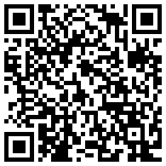
- Working with lists, step by step 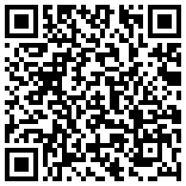
The WCMUSA Manager App keeps the records of World Church of Messiah USA in one place: members, giving, attendance, stock, pilgrimages, follow-up and reports. This chapter shows you how to sign in, find your way around, understand what your account lets you see, and work with the lists that appear on almost every page.
Who can use this: Everyone with an account. National / Admin, Regional, Admin Assistant and Local all sign in the same way. What each role can open and see is explained in Roles: what you can see.

Signing in
You sign in with the email address and password your administrator gave you.

How to sign in
- Open the app link: https://wcmusa.knack.com/manager-v2-app
- Type your Email Address.
- Type your Password.
- Tick Remember me if you use your own computer and want to stay signed in.
- Click Sign In.
- The Home page opens and the menu appears down the left side.
If you forgot your password, click Forgot? next to Password.
Some parts of the app, such as Membership and Follow-up, have their own sign-in box. If you are already signed in, you go straight through and do not have to sign in again.
Tip: The menu on the left only appears after you sign in. If you do not see it, you are not signed in yet.
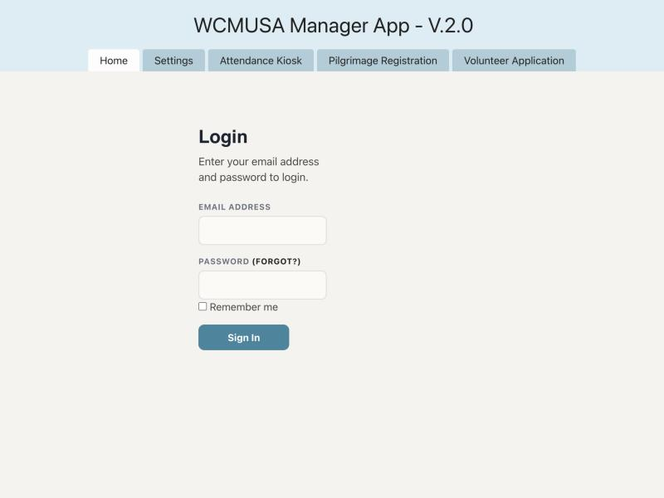
The sign-in box

Your account settings and password
The Account Settings page lets you change your name, your email address and your password. It is not in the left menu. Open it with the Account Settings link at the top right of every page, next to your name and Log Out.

How to change your name or email
- Click Account Settings at the top right of the page.
- In the Account Settings box, change Name or Email.
- Click Submit.
- The message “Your account settings have been updated.” appears.

How to change your password
- Click Account Settings at the top right of the page.
- In the Change Password box, type your Current Password.
- Under New Password, type the new password, then type it again to confirm it.
- Click the button under the box to save.
- The message “Password successfully changed.” appears.
Important: If you change your email, use the new email the next time you sign in.
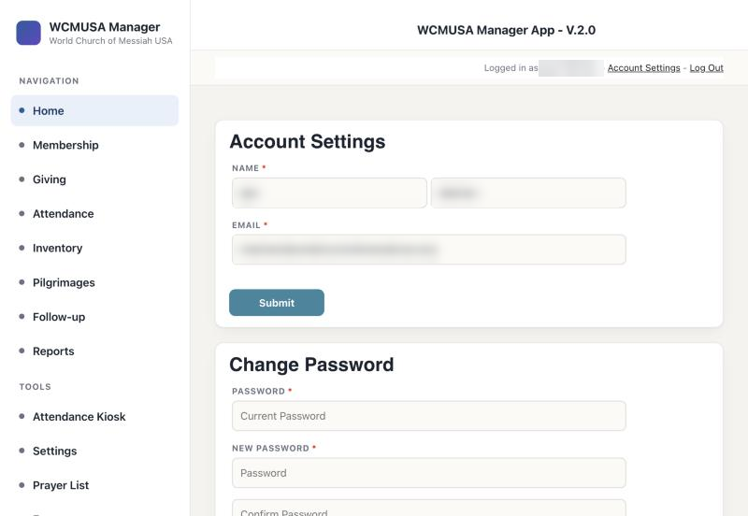
The Account Settings page with its two boxes

The menu on the left
The left menu is on every page once you are signed in. The page you are on is highlighted.
At the top is the name of the app, WCMUSA Manager, with “World Church of Messiah USA” under it.
Navigation
Menu item | What it is for
Home | Your dashboard: summary charts and a map.
Membership | Lists of members; open, add and edit members. See chapter 2.
Giving | Donations, count and deposit reports, and online donations. See chapters 5 and 6.
Attendance | Checking people in and the attendance list. See chapter 4.
Inventory | Church stock and orders. See chapter 8.
Pilgrimages | Pilgrimage trips and applications. See chapter 9.
Follow-up | Pastoral follow-up notes and meetings. See chapter 3.
Reports | All the reports of the app. See chapter 7.
Tools
Menu item | What it is for
Attendance Kiosk | The self check-in screen for a tablet at the church entrance. See chapters 4 and 11.
Settings | The list of churches. See chapter 12.
Prayer List | The prayer list. Only shown if your account may use it. See chapter 3.
Events | Retreats, HQ volunteers and meal events. Only shown if your account may use it. See chapter 10.
At the bottom of the menu is the Viewing as panel (see below), and under it the build number of the app, for example “build 2026-10-20.3”.
Important: If the build number is shown in red with the word “INCOMPLETE”, the app is not set up correctly. Tell your administrator.
The menu shows the same main pages to everyone. Opening a page does not mean you see every record on it: you only see the records of the churches your account can reach.
On a narrow screen, such as a phone, the menu becomes a strip across the top of the page and the Viewing as panel is hidden.
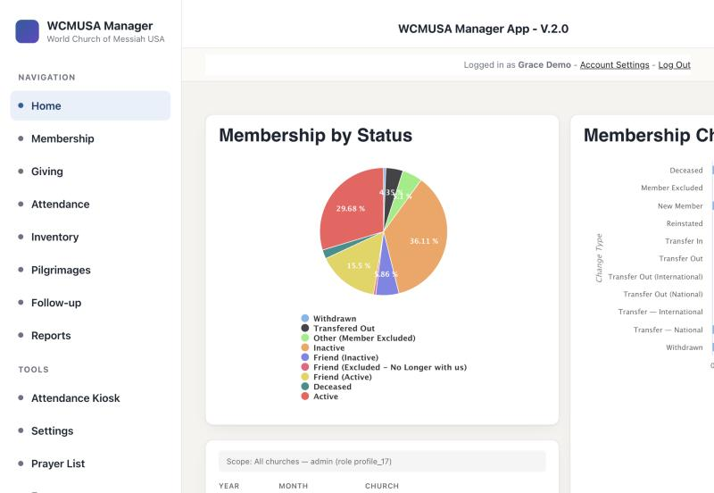
The left menu, with Navigation, Tools and the Viewing as panel

Roles: what you can see
Every account has one role. Every account also has a list of Regions and Churches it can reach. The role decides which pages you can open. The churches decide which records you see on those pages.
Role | Pages you can open | Records you see
National / Admin | Every page, including All Notes. | All churches.
Regional | Home, Membership and the other main pages, Follow-up, and the Family and Follow-up tab on a member. | Only the churches your account can reach.
Admin Assistant | Home, Membership and the other main pages. Not Follow-up. | Only the churches your account can reach.
Local | Home, Membership and the other main pages. Not Follow-up. | Only the churches your account can reach.
Some things are only for certain accounts:
- All Notes (every follow-up note from every church) is only for National / Admin.
- Bulk delete on lists is only for National / Admin.
- The Prayer List is for National / Admin and for the Regional accounts the administrator has turned it on for.
Tip: The Admin Assistant role works like Local: it sees only its own churches. It is not a national role.

The “Viewing as” panel
The Viewing as panel at the bottom of the left menu tells you who you are signed in as and what you can reach.
It shows:
- Your name. Point at it to see your email.
- Your role. National / Admin is shown in green.
- Regions: the regions you can reach. National / Admin shows “All regions”.
- Churches: the churches you can reach. National / Admin shows “All churches”.
If Churches says “None recorded”, your account has no churches yet. Pages that show church records will look empty. Ask your administrator to add your churches.
The panel only shows your access. You cannot change your role or churches here.
Tip: If a list looks shorter than you expected, look at the Viewing as panel first.

The Home page
Home is the first page you see after signing in. At the top is a menu with Membership, Giving, Attendance, Inventory, Pilgrimages, Follow-up, Reports and All Notes. All Notes is only shown to National / Admin.
Below the menu are summary panels:
- Attendance by Activity
- Member Residences: a map of where members live
- Membership by Status
- Membership Changes by Type
- Giving by Church
- Pilgrimage Applications by Status
- Inventory On Hand by Church
- Who We Are Leaflets by Church
- SDGs Leaflets by Church
- a giving summary
Every panel counts only the churches your account can reach. A Local account sees the numbers for its own church. A National / Admin account sees the whole country.
The Home page for National / Admin

Working with lists
Most pages show records in a list (a table). The lists all work the same way.

How to find a record
- Click in the Search by keyword box above the list.
- Type part of a name or another word.
- Click Search or press Enter. The list shows only the matching rows.
- To see everything again, clear the search box and click Search.
Some lists also have Add filters, to show only rows that match a condition. A list may already have a saved filter. It is shown as a grey label next to Add filters, for example “Count Date is during the current month”. Click the small cross on the label to remove it.

How to sort a list
- Click a column heading. The list is sorted by that column.
- Click the same heading again to sort the other way.

How to move between pages
Long lists are split into pages, for example of 100 rows. Above the list you see how many rows there are, for example “Showing 1-100 of 464”. Use the page box and the arrows next to it to move to the next page. The per page box changes how many rows each page shows.

How to export a list
- Click Export above the list.
- Choose a file type, for example CSV.
- The file downloads to your computer. It holds the rows you are allowed to see.

How to open, edit or delete one record
Each row has links, for example View, Edit and Delete. On some lists the link that opens the record is an eye icon in the Details column.
- View (or the eye icon) opens the full record.
- Edit opens a form to change it. Click the save button at the bottom when you are done.
- Delete removes the record for good.
Important: Delete cannot be undone. Make sure you have the right row.
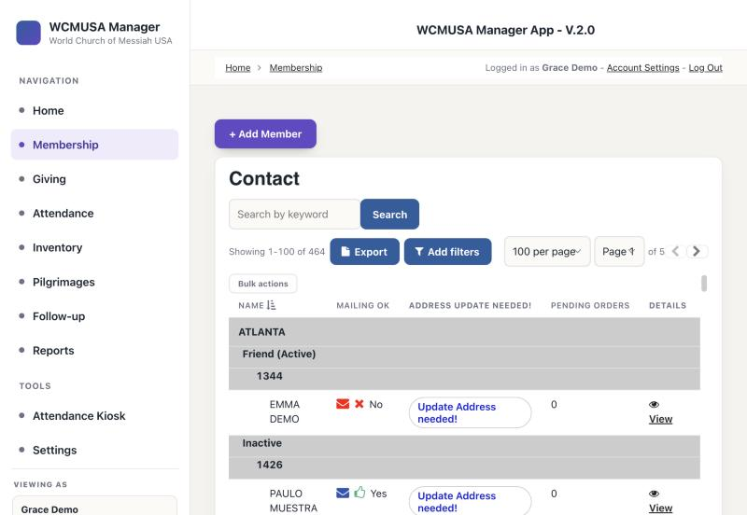
A list with its search box, Export, Add filters and Bulk actions

Changing many rows at once (bulk edit)
Many lists have a Bulk actions button above them. It lets you change one column on many rows at once. National / Admin can also delete many rows at once.
You can only change records of the churches your account can reach. The app checks every row.

How to change many rows at once
- Click Bulk actions. The list turns amber and a tick box appears on each row. The bar says “Bulk edit” and “Changes every ticked row at once. This cannot be undone.”
- Tick the rows you want to change. The tick box in the heading ticks every row on this page.
- Next to Set, choose the column to change.
- Next to to, type the new value.
- Click the button. It says exactly what will happen, for example Overwrite Status on 12 rows.
- Confirm in the box that appears.
- Wait while each row is updated. A list shows “ok” or “FAILED” for each row.
- When it is finished, click Done.
If a row is refused, the reason is shown, for example “record belongs to another church”.

How to delete many rows at once (National / Admin only)
- Click Bulk actions.
- Tick the rows to delete.
- Click Delete 12 rows (the number matches your ticks).
- Type DELETE in the box that appears and confirm. If you type anything else, nothing is deleted.
Important: Bulk edit and bulk delete cannot be undone. You can change at most 200 rows at a time.
Tip: If the button says Tick some rows first, no rows are ticked yet. If it says Nothing editable here, this list has no columns you can change in bulk.

Troubleshooting
A page says you are not signed in, or stays empty, after you reload it. If you reload a page in your browser, some pages, such as the Prayer List or the roster on Pilgrimages, may say “not signed in” or show nothing. The page asked for its records before your sign-in was ready. Click another item in the left menu, then come back to the page. You can also wait a moment and click the menu item again. You do not need to sign in again.
A page takes a long time to open. Some pages collect a lot of records. The Prayer List, for example, can take up to about 20 seconds. Wait until the loading message goes away.
A list looks shorter than you expected. Check the Viewing as panel. You only see the records of the churches your account can reach.

Getting help
- If a page looks empty, check the Viewing as panel. If Churches says “None recorded”, ask your administrator to give you access.
- If you cannot open a page, your role may not include it. See Roles: what you can see.
- If the build number at the bottom of the menu is red and says “INCOMPLETE”, tell your administrator.
- For anything else, contact your administrator. Tell them the page you were on, what you clicked, and any message you saw.

Quick reference
Task | Where | Who
Sign in | App link, sign-in box | Everyone
Change name, email or password | Account Settings page | Everyone
See your role and churches | Viewing as panel, bottom of the left menu | Everyone
See the summary charts | Home | Everyone (own churches)
Search, sort, export a list | Above and under any list | Everyone
Change many rows at once | Bulk actions above a list | Everyone (own churches)
Delete many rows at once | Bulk actions above a list | National / Admin
Open every follow-up note | Home, All Notes | National / Admin

2. Members
Videos for this chapter
- Adding a member, step by step 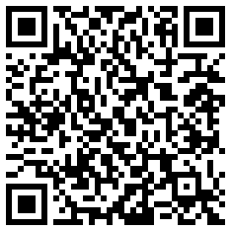
- Logging a membership event, step by step 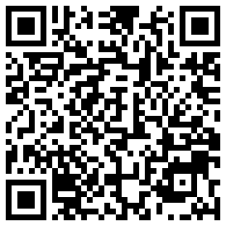
- The member page, step by step 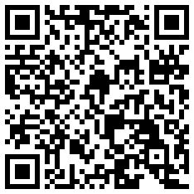
The Membership part of the app is where you keep the record of every member and friend of the church. You can find a person, open their page, add someone new, record a change such as a transfer or a passing, link family members, and print a membership card with a QR code for check-in.
Who can use this: National / Admin — all members. Regional, Admin Assistant and Local — only members of the churches your account can reach. The Family and Follow-up tab on a member is only for National / Admin and Regional.

The membership lists
Click Membership in the left menu. The page has a + Add Member button and three lists. Each list has a search box and an Export button, shows 100 rows per page and is sorted by name.
- Contact: the current members and friends, grouped by church, then by membership status and Registrant Number. People who are deceased, transferred out or excluded are not in this list. Columns: Church, Membership Status, ID Number (the Registrant Number), Name, Mailing OK, Address update needed!, Pending Orders, Details (with the View link), Edit, Delete.
- Contacts at Local Church: a shorter list of current people. Its View Member Details link opens a simple read-only page with the person’s contact details and no tabs.
- Excluded and transferred out: everyone who is not active or inactive, such as people who are deceased, transferred out or excluded. It also shows To Church, To Country and Reason.
What the columns mean:
- Mailing OK: a blue envelope with a thumbs-up means the person may receive mail. A red envelope with a cross means they may not.
- Address update needed!: shows the link “Update Address needed!” when the person has no address. Otherwise it is blank.
- Prayer list: if your account uses the prayer list, a Prayer list column appears at the left of the Contact and Contacts at Local Church lists. See chapter 3.

How to find a member
- Click Membership in the left menu.
- Type part of the name in the search box above the list.
- Click Search or press Enter.
- Click View in the Details column to open the member’s page.
Important: Delete removes the member and cannot be undone. To record that someone left, use + Log Event instead (see below).
The Membership page with its three lists

The member page (Member Details)
Click View on a member’s row to open their page. From top to bottom you see:
- The tabs: Back, Giving, Family and Follow-up, Purchases, Attendance.
- Member Actions: the + Log Event and + Add Relationship buttons.
- The membership card: initials, name, church, Registrant Number, status, a QR code and a Print card button.
- Contact Details: Pending Orders, Registrant Number, Name, Email, Phone, Address, Mailing OK, Date of Birth, Primary Language, Special Notes / Observations, Membership Status, Church, Region. At the bottom of this box is the Magazine received log.
- Residence & nearest church: a map.
- Prayer list: a card, only if your account uses the prayer list.
- Membership History: every membership event, newest first: When, Event, To Church, To Country, Reason, Notes.
- Family: the person’s family members.
Tip: In Contact Details, the Registrant Number is shown under the label Internal Sequence (unused). It is the same number as on the card.

The tabs
- Giving: a giving summary, the list of donations, a chart of this year, and a form to record a donation. See chapter 5.
- Family and Follow-up: follow-up notes, meetings and family. Only for National / Admin and Regional. See chapter 3.
- Purchases: the person’s orders, and the form Record a Purchase for This Member.
- Attendance: the person’s check-ins, and the form Check This Member In.
- Back: returns to the Membership page.
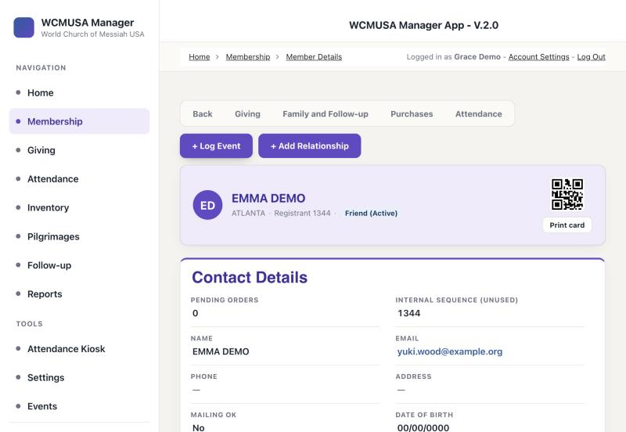
A member page, top part

Adding a member
Every new member gets a Registrant Number automatically. It continues the church’s original numbering.

How to add a member
- Click Membership in the left menu.
- Click + Add Member. A form opens.
- Look at Registrant Number. It shows “assigning…” and then fills in the next free number. Leave it as it is.
- Type the Name, Email, Phone and Address.
- Tick Mailing OK if the person may receive mail.
- Choose the Church and the Region.
- Fill in Date of Birth, Profession of Faith Ceremony Date and Primary Language.
- Choose the Membership Status, for example Active or Friend (Active).
- Add anything else in Special Notes / Observations.
- Click the submit button. The message “Form successfully submitted.” appears.
What happens next:
- A New Member event is added to the person’s Membership History, dated on the Profession of Faith Ceremony Date.
- If two people add a member at the same moment and get the same number, the second one is moved to the next free number. A message tells you, for example “Registrant number 1520 was taken while you were typing. This member has been given 1521 instead.”
- If the number box shows “enter a number”, the app could not find the next number. Type the number yourself.

Someone transferring in from overseas
If the person is a member of a World Church of Messiah overseas and is transferring to the USA:
- Choose the country in Transferred In From (Country).
- Type the date of the transfer in Status Change Date.
The app then records a Transfer In event instead of a New Member event.
Tip: Gender is not on this form. After saving, open the member and use Edit to set Gender. The app needs it to name family relationships correctly.
Important: The Registrant Number is printed on the membership card and in its QR code. Do not change it once it is given.

Editing a member

How to edit a member
- On the Membership page, find the person.
- Click Edit on their row.
- Change the fields you need. The edit form also has Gender and Secondary Language.
- Click the save button at the bottom.
When you change Membership Status on this form and fill in Status Change Date, the app adds a matching event to Membership History, for example Withdrawn or Transfer Out.
Tip: To record a change such as a transfer or a withdrawal, + Log Event is the easier way. It sets the status and Mailing OK for you.

Logging a membership event
A membership event records a change in a person’s membership: joining, transferring, leaving, being reinstated or passing away. Events appear in Membership History on the member page and in Reports, Membership Changes (see chapter 7).

How to log an event
- Open the member’s page.
- Click + Log Event. The form Log a Membership Event opens.
- Choose the Event Date.
- Choose the Event Type.
- Fill in the boxes that appear. Which boxes appear depends on the event:
  - Transfer — National or Transfer Out (National): To Church and Reason.
  - Transfer — International, Transfer Out (International), Transfer Out or Transfer In: To Church, To Country and Reason.
  - Withdrawn, Member Excluded or Reinstated: Reason only.
  - New Member and Deceased: no extra boxes.
- Add any Notes.
- Click the submit button. The message “Event logged.” appears.
The Reason list only shows reasons that fit the event. For example, for Withdrawn you can choose Joined another group, Moved, no transfer requested, Lost contact, Personal request or Other.

How an event changes the member
When you save an event, the app updates the person’s Membership Status and Mailing OK for you:
Event | Status becomes | Mailing OK
New Member, Transfer In, Reinstated | Active | On
Transfer — National, Transfer Out (National) | Active (still a member, at another US church) | On
Transfer — International, Transfer Out (International) | Transfered Out | Off
Withdrawn | Withdrawn | Off
Member Excluded | Other (Member Excluded) | Off
Deceased | Deceased | Off
- If the person is a friend, the friend version of the status is used. For example, Active becomes Friend (Active).
- Only the newest event, by Event Date, decides the status. Correcting an old event does not undo a newer one.
- A message at the bottom of the screen tells you what changed, for example ‘Membership status set to “Withdrawn”, Mailing OK turned off.’
- If the message is red and says the member record was not updated, set the status yourself with Edit.
Important: A transfer to another US church does not move the person to the new church. Use Edit and change Church yourself.

Family relationships
The Family list on the member page shows the person’s family. A relative can be another member in the app, or someone who is not in the app.

How to add a family member
- Open the member’s page.
- Click + Add Relationship. The form Add a Family Relationship opens.
- At Is this person in the system?, choose A member in the system or Not in the system.
- If the relative is in the app, choose them in Related member. If not, type Their name, Their phone and Their email.
- At They are this member’s…, choose what the relative is to this person, for example Wife.
- Add any Notes.
- Click the submit button. The message “Relationship saved.” appears.
What happens next:
- If the relative is in the app, the app also adds the link to the relative’s page. For example, if you add Maria as Owen’s Wife, Maria’s page shows Owen as her Husband.
- The word used on the other page depends on the Gender of the person you started from. If no gender is set, the app uses Spouse, Child, Parent or Sibling.
- If you delete the relationship on one page, it is deleted on the other page too.
- A relative who is not in the app only appears on this person’s page.
Tip: Set Gender on members with Edit so the family words are right.

The membership card and QR code
The top of the member page, and of every tab, shows the membership card: the person’s initials in a circle, their name, their church, “Registrant” with their number, their status and a QR code.
The QR code holds the Registrant Number. The Attendance page and the Attendance Kiosk read it to check the person in.

How to print a membership card
- Open the member’s page.
- Click Print card.
- A small window opens with the QR code, the name, the card code and the church.
- The print box opens. Choose your printer and print.
Tip: If nothing happens when you click Print card, your browser is blocking pop-up windows. Allow pop-ups for this site and try again.
If the person has no Registrant Number, the card shows “Registrant —”.
The membership card at the top of the member page

The neighbourhood map
Under Contact Details is the map Residence & nearest church. It shows where the person lives, other members nearby, and the nearest church.
What you see:
- A line such as “12 members within 25 miles” and the nearest church with its distance.
- An orange button Directions to followed by the church name. It opens driving directions in Google Maps in a new tab.
- A large blue pin for this person.
- Purple pins for other members within 25 miles. Click a pin to see the name, church and distance.
- Red pins with a cross for churches. Click a pin for the address and driving directions.
- A dashed red line to the nearest church.
You only see other members of the churches your account can reach. National / Admin sees everyone. The line may say how many members outside your access are not shown.
Distances on the map are in a straight line. The directions links use driving routes.
If the person has no address, the map says “This member has no address on file, so there is nothing to place on a map.”

The magazine log on the member page
At the bottom of Contact Details is Magazine received. Use it to record that one person received Miracle or Milagre outside a normal mailing, for example a copy handed to them at church.
The mailing report uses the same records, so a logged issue stops a second label being printed for that person.

How to log a magazine
- Open the member’s page.
- In Magazine received, choose the magazine: Miracle (English) or Milagre (Portuguese).
- Type the issue, for example Aug 2026.
- Check the date. It is today unless you change it.
- Choose how it was given: USPS Mail or By Hand.
- Set the number of copies.
- Click Log it. The message “Logged.” appears and the row is added to the list below.

How to correct or remove an entry
- Click Edit on the row, change it, and click Save. Click Cancel to stop without saving.
- To remove a row, click Delete and confirm.
What happens to stock:
- Logging takes the copies out of the stock of that magazine at the person’s church.
- Editing moves only the difference.
- Deleting puts the copies back.
Important: Always type the issue. Without it the app cannot stop a duplicate label later, and it asks you to confirm.
Important: Deleting an entry cannot be undone, and the person can get a label for that issue again.

Recording a passing
There are two ways to record that a member has passed away.

How to record a passing with Log Event
- Open the member’s page.
- Click + Log Event.
- Choose Deceased as the Event Type.
- Set the Event Date to the date of passing.
- Click the submit button. The status becomes Deceased and Mailing OK is turned off.

How to record a passing with Edit
- On the Membership page, click Edit on the person’s row.
- Set Membership Status to Deceased. The Date of Passing box appears.
- Type the Date of Passing.
- Type the Status Change Date.
- Click the save button.
If you correct the Date of Passing later, the app also corrects the date of the Deceased event in Membership History.

The Giving tab
Click the Giving tab on a member’s page to see their giving. At the top is the Giving Summary:
- Total given in their lifetime, their Last gift and their Giving streak in months.
- This month, this quarter and this year, each compared with the period before.
- What was tax deductible this year and last year, and Other receipts such as purchases and pilgrimage costs, which are not counted as giving.
Under the summary are the donations list, the chart Donation Trend — This Year and the form Record a Donation for This Member.
You only see donations given at the churches your account can reach. Chapter 5 explains giving in full.

Changing many members at once
The membership lists have a Bulk actions button. Use it to change one column on many members at once, for example Mailing OK. Chapter 1 explains the steps.
You can only change members of the churches your account can reach. Only National / Admin can delete many members at once.
Important: Bulk changes cannot be undone. To record a status change for one person, use + Log Event instead.

Quick reference
Task | Where | Who
Find a member | Membership, search box | Everyone (own churches)
Open a member’s page | Membership, View | Everyone (own churches)
Add a member | Membership, + Add Member | Everyone
Edit a member | Membership, Edit | Everyone (own churches)
Record a transfer, withdrawal or passing | Member page, + Log Event | Everyone (own churches)
Link family members | Member page, + Add Relationship | Everyone (own churches)
Print a membership card | Member page, Print card | Everyone (own churches)
Log a magazine given by hand | Member page, Magazine received, Log it | Everyone (own churches)
See a member’s giving | Member page, Giving tab | Everyone (own churches)
See follow-up and meetings | Member page, Family and Follow-up tab | National / Admin, Regional
Change many members at once | Membership, Bulk actions | Everyone (own churches); delete: National / Admin

3. Follow-up and prayer
Videos for this chapter
- Logging a follow-up conversation, step by step 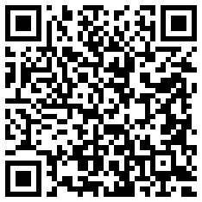
- Using the prayer list, step by step 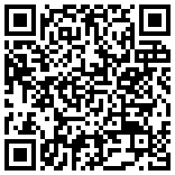
Follow-up is the pastoral care side of the app. You write a short note after each conversation with a member, plan the next meeting, and keep a prayer list of the people the church is praying for. This chapter explains follow-up notes, meetings and the prayer list.
Who can use this: National / Admin — all follow-up notes, including All Notes, and the full prayer list. Regional — Follow-up, the Family and Follow-up tab, and the prayer list if the administrator has turned it on for your account. Admin Assistant and Local — follow-up and the prayer list are not available.

The Follow-up page
Click Follow-up in the left menu. The page has:
- My Follow-Up Notes: the notes you wrote. Columns: Date Created, Meeting Notes, Follow-up Date, Health Update Flag, Contact Type, Topic Tags, Sentiment, Edit, Details.
- Add Follow-Up Note: a form to write a new note.
- Three summary panels: Conversations Logged, Open Follow-Ups by Priority and Upcoming Meetings by Clearance.
Important: This list only shows notes you wrote yourself. Notes written by other people are not shown here.

How to add a follow-up note
- Click Follow-up in the left menu.
- In Add Follow-Up Note, check the Date Created.
- Choose the Member.
- Write what was said in Meeting Notes.
- If you need to follow up, choose a Follow-up Date and a Follow-up Priority: Low, Normal or Urgent.
- Choose the Contact Type: Call, Email, In-Person, Other or Text.
- Choose any Topic Tags.
- Fill in Financial Situation if it applies.
- Tick Health Update Flag if the note is about the person’s health.
- Choose the Sentiment: Concern, Neutral or Positive.
- Choose the Note Level: Area or Admin.
- Click the submit button.
The app records you as the writer of the note automatically.

How to change a note
- Find the note in My Follow-Up Notes.
- Click Edit.
- Make your changes and click the save button.
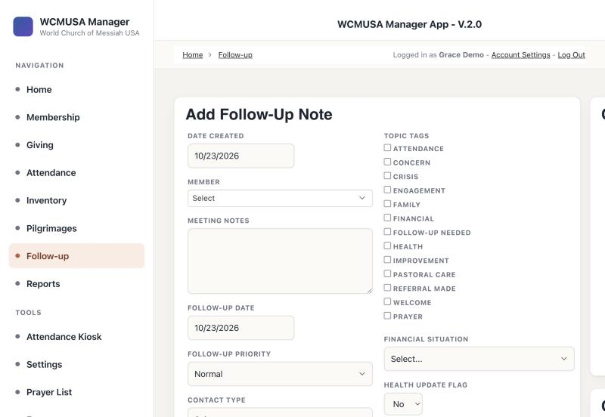
The Follow-up page with the Add Follow-Up Note form

Follow-up from a member’s page
You can also work on follow-up directly from a member. Open the member’s page and click the Family and Follow-up tab. This tab is only for National / Admin and Regional.
The tab shows:
- Follow-Up Actions: + Log a Conversation, Schedule Next Meeting (or Reschedule Meeting when a meeting is already booked), and Follow-Up Notes.
- Next Meeting: the booked meeting, with When, About, Clearance, Scheduled By and Reminder Sent.
- Family: the person’s family.
- Member Actions: + Log Event and + Add Relationship (see chapter 2).
- Follow-Up Notes: the notes you wrote about this person.

How to log a conversation
- Open the member’s page and click the Family and Follow-up tab.
- Click + Log a Conversation. The form Log a Conversation opens.
- Fill in Date Created and Meeting Notes.
- Fill in Follow-up Date, Follow-up Priority, Contact Type and the other boxes as needed.
- Choose the Note Level. The form explains: “Area notes are visible to all staff. Admin notes are visible only on the Follow-Up page.”
- Click the submit button.
The note boxes, shown here on the Follow-up page

How to schedule the next meeting
- On the Family and Follow-up tab, click Schedule Next Meeting. If a meeting is already booked, the button says Reschedule Meeting.
- Choose the Meeting Date & Time.
- Choose the Meeting Status.
- Choose the Clearance.
- Type What is this meeting about?
- Click the submit button. The message “Meeting scheduled.” appears.
The meeting appears in Next Meeting on the tab, and in Upcoming Meetings by Clearance on the Follow-up page.

How to see your notes about one member
- On the Family and Follow-up tab, click Follow-Up Notes.
- A page opens with the notes you wrote about this person.
- Click Details to read a note, or Edit to change it.

All Notes (National / Admin only)
All Notes shows every follow-up note from every church, whoever wrote it. It is only for National / Admin. Other roles do not see the link and cannot open the page.

How to open All Notes
- Click Home in the left menu.
- In the menu at the top of the page, click All Notes.
- The list shows Date Created, Written By, Member, Local Church, Meeting Notes, Follow-up Date, Health Update Flag, Contact Type, Topic Tags and Sentiment.
- Use the search box to find a member or a church. Click Details to read a note.

The prayer list
The prayer list holds the people the church is praying for, with what the prayer is for. Each prayer request is saved as a follow-up note on the person called “Prayer request”, so it also appears among their follow-up notes.
Who can use it: National / Admin sees and manages the whole list. Regional accounts can use it only if the administrator has turned it on for them, and then only for their own churches. If your account cannot use the prayer list, you do not see the Prayer List menu item, the Prayer list column or the Prayer list card.
You can work with the prayer list in three places:
- the Prayer list column at the left of the Contact and Contacts at Local Church lists on the Membership page,
- the Prayer list card on a member’s page, below the map,
- the Prayer List page, under Tools in the left menu.

How to add someone to the prayer list
- On the Membership page, click the box in the Prayer list column on the person’s row. Or, on the member’s page, tick the box on the Prayer list card.
- The box Add to the prayer list opens.
- Type What is the prayer for? This is required.
- Choose one or more Category buttons: Health, Financial, Conflict, Christian Veganism, Accepting Masaaki-sama.
- If you like, choose a Follow up by date.
- Click Add to prayer list. The box in the list now shows a tick.
A person can only have one active prayer request at a time.
Tip: Choosing Health also ticks the Health Update Flag on the note.

How to record a follow-up
- Click Follow up on the person’s Prayer list card or on the Prayer List page.
- The box shows the prayer request.
- Type What happened? This is required.
- Choose How: Call, In-Person, Text, Email or Other.
- If you like, choose a Next follow-up date.
- Click Save follow-up.
The app saves a “Prayer follow-up” note and updates the date of the last follow-up.
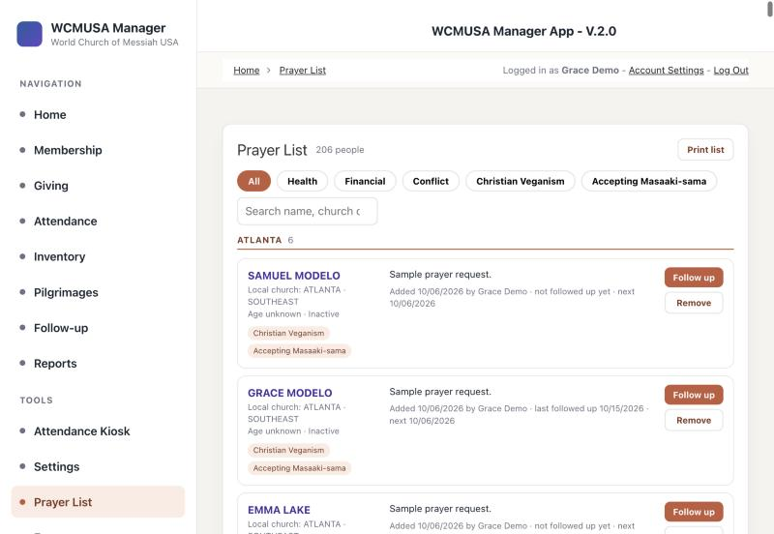
The Follow up and Remove buttons on the Prayer List page

How to take someone off the prayer list
- Click the tick box in the Prayer list column, or click Remove from prayer list on the card, or Remove on the Prayer List page.
- The box asks “Take this person off the prayer list?” with their name.
- If you like, type Why?
- Click Remove from prayer list. Click Keep on list to stop.
The request is not deleted. It stays in the person’s follow-up notes, marked Removed, with the date.

The Prayer List page
Click Prayer List under Tools in the left menu.
The page shows:
- How many people are on the list, and how many are shown.
- A Print list button.
- Buttons to show All or one category.
- A search box: “Search name, church or prayer”.
- The people, grouped by church and then by surname.
Each person shows their name, their local church, their age and status, the categories, what the prayer is for, who added it and when, the last follow-up and the next follow-up date. Click the name to open the member’s page. Each person has Follow up and Remove buttons.
If nobody is on the list yet, the page says so and tells you how to add someone.
Tip: The Prayer List can take up to about 20 seconds to open. While it loads, the page says “Loading the prayer list…”. Wait for it to finish before you click again.
Tip: If you reload the page in your browser, the Prayer List may say you are not signed in, or stay empty. This happens when the page asks for the list before your sign-in is ready. Click another item in the left menu, then click Prayer List again. You can also wait a moment and click it again.
The Prayer List page

Privacy for Regional accounts
If you are Regional, a request added by someone else shows the name only, with the words “Added by someone else. The details are private to them.” You do not see what the prayer is for, the categories, who added it or the dates.
- You can still click Follow up for that person.
- You cannot remove a request someone else added. Only the person who added it, or National / Admin, can remove it.
- “Last followed up” counts only your own follow-ups.

How to print the prayer list
- Open the Prayer List page.
- If you like, choose a category button or search to narrow the list. The printout holds only what is shown.
- Click Print list.
- Choose your printer and print.
The printout is on letter-size paper. It has the title “Prayer List”, the date and the number of people. People are grouped under their church in three columns. Each page has a page number and the date it was printed.

Quick reference
Task | Where | Who
Write a follow-up note | Follow-up, Add Follow-Up Note | National / Admin, Regional
Log a conversation with a member | Member page, Family and Follow-up, + Log a Conversation | National / Admin, Regional
Book or move a meeting | Member page, Family and Follow-up, Schedule Next Meeting | National / Admin, Regional
See your notes about a member | Member page, Family and Follow-up, Follow-Up Notes | National / Admin, Regional
See every note from every church | Home, All Notes | National / Admin
Add someone to the prayer list | Membership, Prayer list column, or the member page card | National / Admin; Regional if turned on
Record a prayer follow-up | Prayer List page or member page card, Follow up | National / Admin; Regional if turned on
Take someone off the prayer list | Prayer List page, Remove | Whoever added it; National / Admin
Print the prayer list | Prayer List page, Print list | National / Admin; Regional if turned on

4. Attendance
Videos for this chapter
- Checking members in, step by step 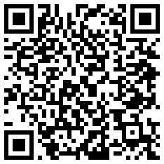
- Setting up the attendance kiosk, step by step 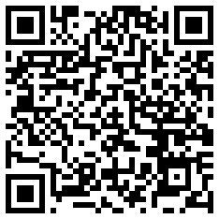
This part of the app records who came to church and to other activities. Staff can check people in on the Attendance page by scanning their membership card or searching for their name. Members can check themselves in at the door on the Attendance Kiosk, a page that needs no login and is meant for a tablet at the church entrance. Church leaders also file one Attendance Report for each service or activity, with the headcounts.
Who can use this: National / Admin — all churches. Regional, Admin Assistant and Local — only the churches in their account. The Attendance Kiosk is a public page: anyone at the device can check in, without a login.

The Attendance page (staff QR check-in)
Open Attendance in the left menu. At the top of the page is the QR Check-In panel. Below it are the Add Attendance form and the Attendances table.
The panel has these fields:
- Local Church — the church where people are checking in. You must choose it first.
- Activity Date — today’s date is filled in for you.
- Activity Type — Church Service, Church Visit, Home Service, Home Gathering or Online Meeting. On the first three Sundays of the month it starts on Church Service. On other days it starts on Church Visit.
- Participant Type — Member, Friend or First-Time.
- Search Member, Selected Member and the button Check In Selected Member.
- Manual QR / Member Value and the button Check In Manually.
- A camera box, Scan Membership QR, with Start Camera and Stop Camera. If your device has more than one camera, a Switch Camera button also appears.
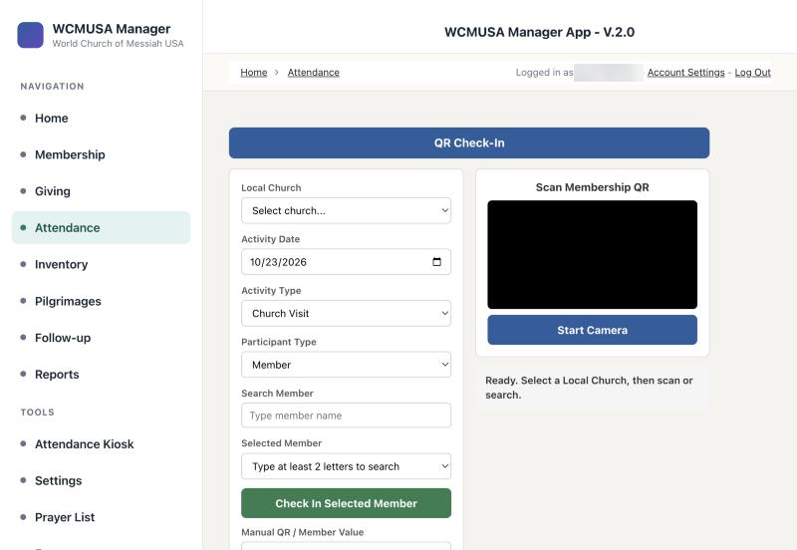
The QR Check-In panel before a church is chosen

How to check someone in with their membership card
- Open Attendance in the left menu.
- Choose the church in Local Church.
- Check Activity Date, Activity Type and Participant Type.
- Click Start Camera. The first time, your browser asks to use the camera. Allow it.
- Hold the member’s card so the QR code faces the camera.
- The app beeps and shows “Checked in:” with the member’s name. A Checked In! message appears for five seconds.
The QR code is printed on the member’s card. You can print a card from the member’s profile (see chapter 2).

How to check someone in by name
- Choose the Local Church and check the other fields.
- In Search Member, type at least two letters of the name.
- Pick the right person in Selected Member.
- Click Check In Selected Member.

How to check someone in by card number
- Choose the Local Church.
- In Manual QR / Member Value, type the member’s Registrant Number, or the code printed under the QR (it starts with WCM-REG-).
- Click Check In Manually, or press Enter.
Search Member, Selected Member and Check In Selected Member
Tip: If a member checks in twice for the same activity on the same day, the app plays a low beep and shows Already Checked In. Nothing new is saved.
Every check-in is also counted in that day’s Attendance Report for the church, date and activity. If no report exists yet, the app creates one for you.
Messages you may see:
Message | What to do
Select a Local Church first. | Choose the church at the top of the panel.
Select a member first. | Search for the name and pick it in Selected Member.
Enter a QR value or member ID. | Type a code or Registrant Number before you click Check In Manually.
Member not found for QR | The card code was not found among your churches’ members. Search by name instead.
Camera permission was blocked | Allow the camera in your browser settings, then click Start Camera again.
No camera was found on this device. | Use the name search or the card number instead.

The Attendance Kiosk (members check in at the door)
The kiosk is a simple screen for a tablet at the church entrance. Members check themselves in. It has no left menu, and it needs no login. It can only look up members by card or by name, and record a check-in.
To open it, click Attendance Kiosk under Tools in the left menu, or open the kiosk link on the tablet.

How to set up a tablet as a kiosk
- On the tablet, open the Attendance Kiosk link.
- The kiosk shows “Detecting your location…”. Allow location if the tablet asks.
- If the tablet is near one of the churches, the kiosk for that church opens by itself. Otherwise you see Select your Local Church, or Nearest church detected — confirm or choose, with a button for each church.
- Tap your church.
- Bookmark the page, or add it to the home screen. Next time the tablet opens straight to your church.
- If the camera faces the wrong way, tap Switch Camera. The tablet remembers your choice.

What members do at the kiosk
- Hold the membership card so the QR code faces the camera.
- Or type your name in Search Member, choose it in Selected Member, and tap Check In Selected Member.
- A Checked In! message welcomes you.
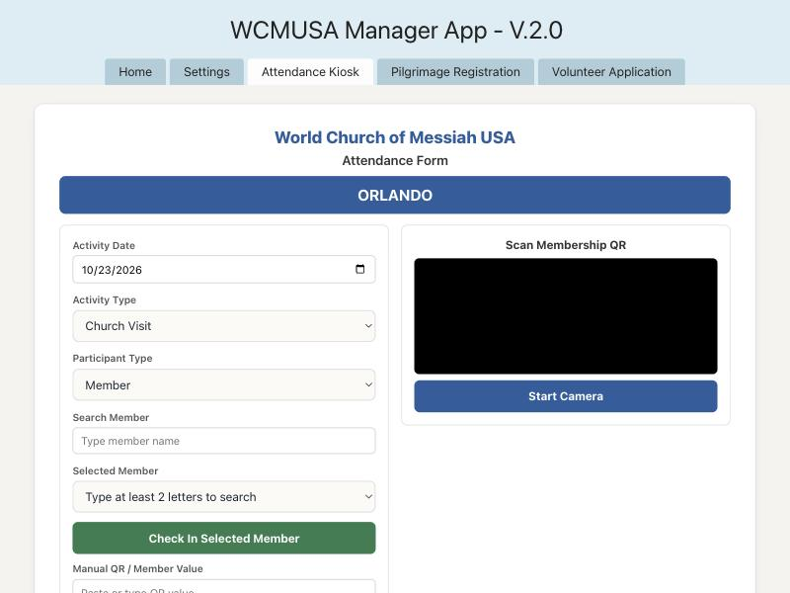
The kiosk screen ready to scan
The kiosk screen shows “World Church of Messiah USA”, “Attendance Form”, the church name, the same date and activity fields as the staff panel, and the status line “Ready. Scan a QR code or search by name.” At the bottom is a Switch Church list. The current church has a star.
Tip: The camera turns off after 30 seconds with no activity. It turns on again as soon as someone taps the screen or types.
Important: If two members share the same card number, the kiosk refuses the card instead of checking in the wrong person. Ask an administrator to correct the duplicate number.
If the kiosk shows “The church list could not be loaded on this device”, tap Try again.

Recording attendance in other ways

The Add Attendance form
Below the QR Check-In panel, the Add Attendance form lets you type a check-in by hand. It has Check-in Time, Activity Type, Participant Type, Check-in Method, Duplicate Check-in?, Notes, Local Church and Member. For a Church Service, it also asks for Online Participation Total and Number of Machines.
Check-in Method can be QR Scan, Manual Search, Walk-in Friend, First Time Visitor, or Correction / Admin Entry. Use Correction / Admin Entry when you add a check-in after the fact.
The Attendances table below it lists the check-ins for your churches. Click Details to see one, or Edit to change it.

From a member’s profile
- Open the member’s page (see chapter 2).
- Click the Attendance tab.
- Fill in the form Check This Member In.
- Click Submit.
The tab also lists every check-in for that member.

Attendance reports
An Attendance Report describes one occasion: a service, a home service, a gathering, an online meeting or another activity, with how many people took part. Local churches file their own reports.
To open it, click Reports in the left menu, then the card Attendance Report.

How to add an attendance report
- Open Reports, then Attendance Report.
- In Add Attendance Report, enter the Date.
- Choose the Activity Type. The form changes to show only the boxes for that type.
- Choose the Region and the Local Church.
- Fill in the counts (see the table below).
- Add Notes if needed.
- Click Submit.
Activity Type | Boxes that appear
Church Service | In Person - Members, In Person - Friends, In Person - First Time, Online Service Attendance, Number of Machines, Host
Home Service | Home Service - Members, Home Service - Friends, Home Service - First Time, Type of Home Service, Host
Home Gathering | Home Gathering / Other Activity, Host
Online Meeting / Study | Online - Members, Online - Friends, Online - First Time
Other Activity | Name, Home Gathering / Other Activity
Church Visit | Daily Attendance

Reviewing reports
Below the form, the reports are listed in separate tables: Church Service Reports, Home Service Reports, Home Gathering or Other Activities, Online Meetings or Studies and Other Activities. Each table shows the current year. Click Edit to correct a report, or Delete to remove it.
Important: Delete removes the report for good.

Quick reference
Task | Where | Who
Check a member in with the camera | Attendance → QR Check-In → Start Camera | All roles
Check a member in by name | Attendance → Search Member → Check In Selected Member | All roles
Check in by card number | Attendance → Manual QR / Member Value → Check In Manually | All roles
Set up a door tablet | Left menu, Tools → Attendance Kiosk → tap your church → bookmark | Anyone; no login
Check yourself in at church | Attendance Kiosk on the tablet | Members; no login
Add a check-in by hand | Attendance → Add Attendance | All roles
Check in from the profile | Member → Attendance tab → Check This Member In | All roles
File a service headcount | Reports → Attendance Report → Add Attendance Report | All roles, own churches

5. Giving
Videos for this chapter
- Adding a donation, step by step 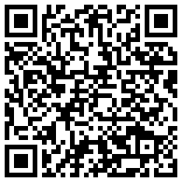
- Filing a Count and Deposit Report, step by step 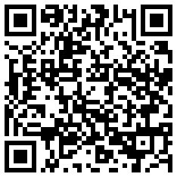
- A member’s giving and donation slips, step by step 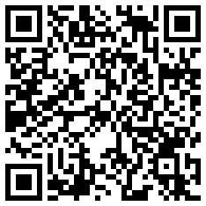
This part of the app keeps every donation and payment the church receives. You use it to record cash and check gifts by hand, to see each member’s giving, to file the collection count and bank deposit, and to print donation slips. Online gifts from Zeffy, Stripe and Zelle come in through the Import Donations page, described in chapter 6.
Who can use this: National / Admin — all churches. Regional, Admin Assistant and Local — only the donations and reports of the churches in their account. Everyone can record donations and file Count & Deposit Reports for their own churches.

The Giving page
Click Giving in the left menu. At the top are two buttons: Count and Deposits and Import Donations. Below them you see:
- the Add Donation form,
- the chart Donation Trend — This Year, beside the form,
- the Donations table, newest first, with a search box.
The Donations table shows the gifts of the current year. Its saved filter, Date is during the current year, is shown next to Add filters. To see older gifts, click the small cross on the filter, or add a filter of your own.
In the Donations table, click the eye icon in the Details column to see a donation, or Edit to change it.
Important: Delete in the Donations table removes the donation for good.
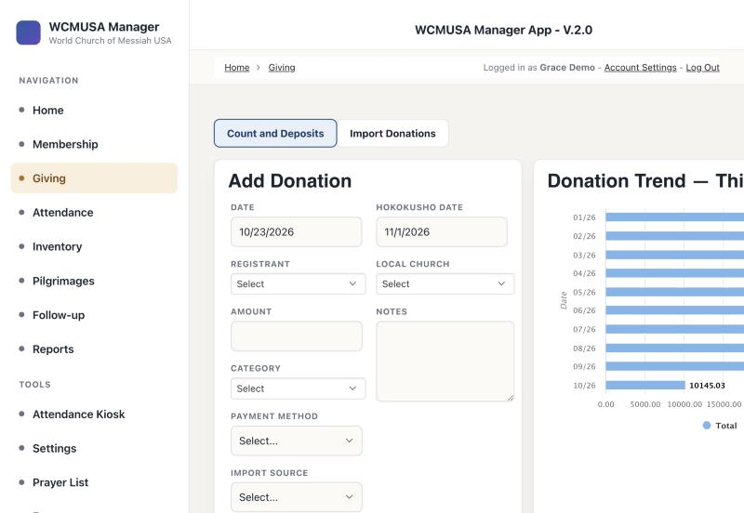
The Giving page with the Add Donation form and the chart

Categories
Every donation has a Category. The number at the start tells you what kind of money it is:
Category | What it is
1-GRATITUDE, 1a-PROFESSION OF FAITH CEREMONY, 1b-BIBLE (DONATION), 2-ENSHRINEMENTS, 3-SPONSORSHIP PROGRAM, 3a - CHORUS | Giving. Tax deductible.
4-FUNDRAISER | Giving, but not tax deductible.
5-SACRED OBJECTS, 6-REIMBURSEMENTS, 6a-BIBLE (COST), 6b-PIN (COST), 7-PILGRIMAGE, 8-GRAND CEREMONY TO CELEBRATE | Purchases, cost recovery and trip payments. Not counted as giving.

Adding a donation
Use the Add Donation form for cash, checks and anything else that did not come in through the online import.

How to record a donation
- Click Giving in the left menu.
- In Add Donation, enter the Date of the gift.
- Choose the member in Registrant.
- Enter the Amount.
- Choose the Category.
- Choose the Payment Method: Cash, Check, Online or Other.
- Leave Is this a regular donation? on Donation for an ordinary gift.
- Check the Hokokusho Date. The app fills it in for you (see below).
- Choose the Local Church where the gift was given.
- If you have already filed the count, choose its Count & Deposit Report.
- Add Notes if needed.
- Click Submit. You see “Form successfully submitted.”
A donation saved on this form is marked Approved right away.
The Add Donation form

The Hokokusho Date
The Hokokusho Date is the reporting month the gift belongs to. When you enter the Date, the app fills it in:
- Cash, check and other gifts entered by hand: a gift dated on or before the 21st goes to the 1st of that month. A gift dated after the 21st goes to the 1st of the next month.
- Online gifts: always the 1st of the month the gift came in.
For example, a cash gift on October 23 gets the Hokokusho Date November 1.
To count a gift in a different month on purpose, type over the date. The app keeps your value. On an Edit Donation form, the app never changes a Hokokusho Date that is already there.
Hokokusho Date filled in for a cash gift on the 23rd

The Local Church and the region
Choose the church where the gift was given, not the member’s home church. For example, a member from Los Angeles who gives in Orlando counts for Orlando.
You never set the region of a donation. The app takes it from the Local Church when you save. If you later change the Local Church, the app corrects the region a moment after you save. If a report shows a gift under the wrong region, check its Local Church.

How to record a payment toward a Sacred Objects order
When a member pays for an order (for example, a sacred object), record the payment as an order payment. The order then shows how much is paid and how much is still owed.
- In Add Donation, choose the member in Registrant.
- Set Is this a regular donation? to Order Payment. The Customer Order box appears.
- Open Customer Order. It lists the member’s orders that still owe money, with the balance and total.
- Pick the order. If Amount is empty, it fills in with the full balance.
- For a partial payment, change the Amount.
- Fill in the other fields and click Submit.
If the box says “No unpaid orders for this member”, the member owes nothing on any order. If it says “Choose the member first”, pick the Registrant first.

Pilgrimage payments
A payment for a pilgrimage can be counted toward the member’s trip registration. The app then updates what is paid, what is still owed, and the payment status of the registration.

How to record a pilgrimage payment
- On a donation form, choose the member.
- Set Category to 7-PILGRIMAGE. A pink box appears: Apply to pilgrimage registration.
- Choose the trip registration. If the member has only one, it is already chosen.
- To save the donation without linking it, choose — Don’t link —.
- Click Submit.
- A message at the bottom right confirms the payment, for example “Applied to the pilgrimage registration. Paid $500, $1,200 still owed. Status: Paid Deposit.”
The payment status moves from Unpaid to Paid Deposit, Paid Deposit & Some and Paid in Full as payments come in.
Tip: If the member has no registration for an upcoming trip, the donation is saved without a link. If something goes wrong, the donation is still saved and the message tells you to link it from the Pilgrimages roster instead (see chapter 9).
A donation can pay toward one registration only. Linking it to a different registration removes it from the first one.

A member’s Giving tab
Every member profile has a Giving tab with that member’s history.

How to see a member’s giving
- Open Membership and click View on the member’s row.
- Click the Giving tab.
At the top, the Giving Summary shows three rows of cards:
- Total given (lifetime) with the number of gifts, Last gift with its date, and Giving streak (how many months in a row the member has given).
- This month, This quarter and This year, each compared with the period before.
- Tax deductible for this year and last year, and Other receipts (lifetime).
The summary counts only categories 1 to 4 as giving. Categories 5 and up appear under Other receipts. Donations marked Ignored or Duplicate are left out.
Below the summary are the chart, the member’s Donations table, and the form Record a Donation for This Member.

How to record a gift from the member’s tab
- On the member’s Giving tab, scroll to Record a Donation for This Member.
- Fill in Date, Category, Amount, Payment Method and Local Church.
- Set Donation Status to Approved.
- Click Submit. The summary updates.
Important: On this form you choose the Donation Status yourself. For a gift you have received, choose Approved.

Count & Deposits
After each collection, two counters count the money and someone takes it to the bank. The Count & Deposit Report records the count, the deposit, and how much went into each category.
Click Giving, then Count and Deposits. The list shows the reports for your churches for the current month, grouped by church. Its saved filter, Count Date is during the current month, is shown next to Add filters. Click the small cross on the filter to see older reports.
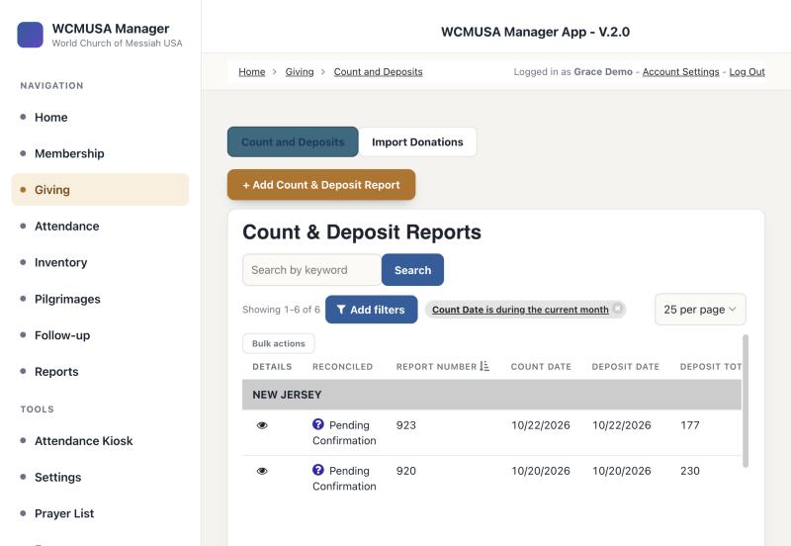
The Count & Deposit Reports list

How to file a Count & Deposit Report
- Click Giving, then Count and Deposits.
- Click + Add Count & Deposit Report.
- Enter the Count Date and choose the Local Church.
- Enter 1st Counter’s Name and 2nd Counter’s Name.
- Enter the Deposit Date and Depositor’s Name.
- Enter the amount for each category, from 1-Gratitude Amount to 7-Pilgrimage Groundfare. Leave a box empty if there was nothing in that category.
- Upload the Written Report Image (a scan or photo of the paper count).
- Upload the Deposit Receipt Image (the bank receipt).
- Add Observations / Notes if needed.
- Click Submit.
You do not add up the total. The app works out the Deposit Total from the category amounts.

The confirmation
After you submit, a box appears: Report Submitted! It shows the Report ID and the date. Click Done, or press Esc, to close it.
Tip: Write the Report ID on the paper count sheet.

Linking donations to a report
Each donation can be linked to a report. Choose the report in the donation’s Count & Deposit Report box when you add or edit the donation.
On the list, click the eye icon in the Details column to open a report. The table Donations in this Deposit lists the donations linked to it. Use Cash Donations, Check Donations or All Donation Types to filter it.
A new report has Reconciled set to Pending Confirmation.

The printable Count & Deposit report
The app can rebuild the paper “Donation Count - Report” form from a report, so you can print it or save it as a PDF.

How to print the count report
- Open Count and Deposits and click the eye icon in the Details column of the report.
- Click Print / attach count report. A full-page sheet opens.
- Click Print to print it.
- Or click Save PDF to Written Report to save it as a PDF on the report.
- Click Close when you are done.
The sheet shows the report number (and the old paper number, if there is one), one column for each category with Cash, Checks and Totals rows, the Total Deposit, the notes, the date, and lines for the two counters’ names and signatures.
The Totals row is what the counters entered. Cash and Checks come from the linked donations. If they do not agree, the sheet prints a Does not reconcile box with both amounts.
Important: Save PDF to Written Report replaces any scan already saved in Written Report Image. The old file cannot be recovered. To keep a scan, use Print only.

Printing donation slips
You can print paper donation slips for the gifts you choose. The bar Print donation slips appears above donation tables: on the Giving page, on a member’s Giving tab, on Imported — Pending Review, and on Donations in this Deposit.

How to print donation slips
- Search or filter the table to show the gifts you want.
- Tick the box at the left of each gift, or tick Select all. The bar shows how many are selected.
- Choose Per page: 4 or 1.
- Click Print donation slips. Your browser’s print window opens.
- Print.
Each slip shows “World Church of Messiah USA”, the H.S. Date (the Hokokusho Date), the date, first and last name, the category and amount, the payment method (Cash, Check, Zelle, Online or Other), notes and the total. With four per page, the page prints sideways so you can cut it into four slips.
Tip: If you click Print donation slips with nothing ticked, the app asks you to tick at least one donation first.
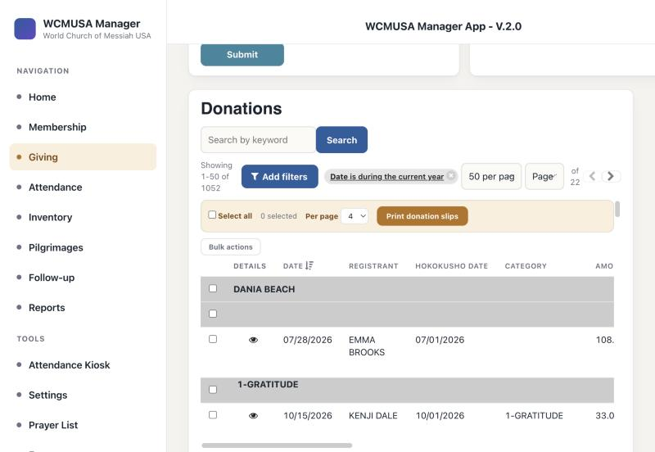
Donation slips selected for printing

Quick reference
Task | Where | Who
Record a cash or check gift | Giving → Add Donation | All roles
Record a payment toward an order | Add Donation → Is this a regular donation? = Order Payment | All roles
Record a pilgrimage payment | Donation form → Category 7-PILGRIMAGE → Apply to pilgrimage registration | All roles, own churches
See one member’s giving | Member → Giving tab | All roles
File the collection count | Giving → Count and Deposits → + Add Count & Deposit Report | All roles, own churches
Print the count report | Count & Deposit Report details → Print / attach count report | All roles
Print donation slips | Any donations table → tick rows → Print donation slips | All roles
Bring in online gifts | Giving → Import Donations (chapter 6) | National / Admin, Regional, Admin Assistant

6. Online donations
Videos for this chapter
- Importing online donations, step by step 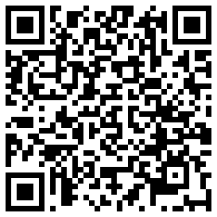
Gifts made online through Zeffy or Stripe, and gifts sent by Zelle, do not need to be typed in by hand. The Import Donations page brings them into the app, matches each gift to a member, and lets you check everything before it is saved. Imported gifts are saved as Pending. A second check, in the table Imported — Pending Review, approves them.
Who can use this: National / Admin — all churches. Regional and Admin Assistant — only the members and donations of their own churches. Local accounts cannot use this page: the app sends them back to the Giving page.

The Import Donations page
Click Giving in the left menu, then Import Donations.
At the top, a blue strip shows when the last imports ran: Last Zeffy sync, Last Stripe sync and Last Zelle CSV import.
Below it you see:
- the box Sync Donations to Knack, with the buttons Sync from Zeffy, Sync from Stripe, Upload Zelle Bank CSV and Refresh,
- the box Reset Last Sync Date and Time,
- the table Imported — Pending Review.
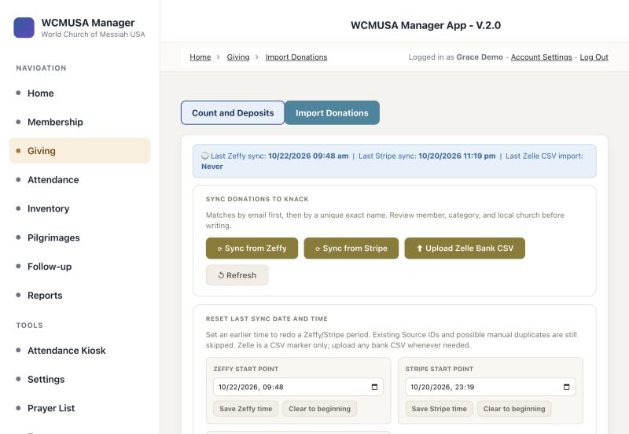
The Import Donations page before a sync

Syncing from Zeffy or Stripe
A sync fetches every gift made since the last sync.

How to sync from Zeffy or Stripe
- Open Giving, then Import Donations.
- Click Sync from Zeffy or Sync from Stripe.
- Wait while the Activity Log shows the progress.
- Read the four counters: Fetched, Email matches, Name matches and Need review.
- Check every row in the review table (see below).
- Click Write to Knack.
- Wait for “Done!” in the log, with the number written and the number of duplicates skipped.
- The page reloads. The new gifts appear in Imported — Pending Review.
For Stripe, a Bank Payout Groups table also lists each bank deposit: the payout, the arrival date, how many donations, and the total. Gifts not yet paid out are counted below it. This helps you match the gifts to your bank statement.

Uploading a Zelle bank CSV
Zelle gifts arrive in the bank account. You bring them in from the bank’s transaction file.

How to upload a Zelle bank file
- In your online bank, download the transactions as a CSV file.
- On Import Donations, click Upload Zelle Bank CSV.
- Choose the file.
- Every row with money coming in is treated as a Zelle gift. The category starts as 1-GRATITUDE, and the donor name is read from the bank description.
- Check every row in the review table, especially Category, member and Local Church.
- Click Write to Knack.

Checking the review table
The review table is titled Review all followed by the number of records. Each row is one gift. The columns are: Status, Possible Duplicate, Email, Name, Amount, Date, Form Title, Category, Member ID and Local Church. Stripe rows also show the payout date and payout.

Match status
The Status badge tells you how the gift was matched to a member:
Status | Meaning
matched | Matched by email address.
matched_name | Matched by an exact name that only one member has (also tried with last name first).
ambiguous_name | More than one member has this name. Type the right Registrant Number.
unmatched | No member found. Type the Registrant Number if you know who it is.
no_email | The gift had no email address.
manual | You typed the Registrant Number.
invalid_id | The Registrant Number you typed was not found.
The app only matches members of the churches your account can see.

How to fix a row
- Category — check the category. The app guesses it from the Zeffy or Stripe campaign title. For example, a title with “enshrinement” gets 2-ENSHRINEMENTS, and anything not recognised gets 1-GRATITUDE. Change it if needed.
- Member ID — to match a gift by hand, type the member’s Registrant Number.
- Local Church — choose the church the gift is for. Every row needs one.
Important: Only rows with a member are written. A row with no member, or with no Local Church, is left out. Check Local Church on every row before you click Write to Knack.

Possible duplicates
The Possible Duplicate column shows No, Possible duplicate or Not checked (when there is no member yet).
Possible duplicate, in yellow, means the same member already has a donation with the same date and amount, for example because someone typed it in by hand. That row is skipped when you write. If it really is a second gift, enter it by hand on the Giving page.

How to remove a row from the import
- Click × at the left of the row.
- The app asks if you want to remove it from this import. Click OK.
The row is not written. Nothing already saved in the app is changed.
To empty the whole review list, click Clear results. Nothing already saved is changed.

Writing to the app, and duplicate protection
When every row looks right, click Write to Knack. The app saves each gift as a donation with:
- the date, amount, member, category and Local Church (the region follows the church),
- Hokokusho Date on the 1st of the month the gift came in,
- Payment Method set to Online,
- the source (Zeffy, Stripe or Zelle),
- Donation Status set to Pending,
- the Campaign and Notes (see below).
The app protects you from saving the same gift twice:
- A Zeffy or Stripe payment that is already in the app is skipped. The log says “Skipped duplicate”. For Zelle, a row with the same date, amount, name and description is skipped.
- If the app cannot check for duplicates at that moment, it skips the row instead of risking a copy. Run the import again later.
- A Possible duplicate row is skipped.
So it is safe to run a sync again.
When a sync finishes cleanly, the last-sync time moves to now, and the next sync fetches only newer gifts. If any row had an error, the log says the last-sync date was not moved. Fix the problem and sync again.

The Campaign and the notes
Each imported gift keeps its Campaign: the name of the campaign page in Zeffy, the description in Stripe, or “Zelle Bank CSV”.
The Notes are filled in for you:
- Zeffy: “ZEFFY UPLOAD -” followed by the campaign page title, exactly as Zeffy names it.
- Stripe: “STRIPE UPLOAD -” followed by the kind of gift, for example “STRIPE UPLOAD - ENSHRINEMENT”.
- Zelle: “ZELLE UPLOAD -” followed by the bank description and reference.
A sync also fills in the Campaign on older Zeffy and Stripe gifts that do not have one yet. Notes that a person typed are never changed.

Reset Last Sync Date and Time
Use this box to fetch an earlier period again, for example all gifts since October 1.

How to sync an earlier period again
- In Zeffy start point or Stripe start point, choose a date and time.
- Click Save Zeffy time or Save Stripe time.
- To fetch everything from the very beginning, click Clear to beginning instead.
- Run Sync from Zeffy or Sync from Stripe again.
Gifts already in the app, and possible duplicates, are still skipped. Nothing is counted twice.
The Zelle CSV import marker is only a reminder of when you last uploaded a bank file. Click Save Zelle marker to set it, or Clear marker to clear it. It does not limit what you can upload, and it is kept on this computer only. Another computer shows “Never”.
The Reset Last Sync Date and Time box

Imported — Pending Review
Imported gifts stay Pending until someone reviews them. The table Imported — Pending Review lists the pending gifts for your churches, newest first.
The columns are Date, Donor, Email, Matched Member, Amount, Campaign, Category, Local Church, Source, Batch, Payout, Status, Notes, Fix and Review.

How to review an imported gift
- Scroll down to Imported — Pending Review.
- Check the donor, matched member, amount, campaign, category and Local Church.
- If something is wrong, click Fix. Correct the donation in the form and click Submit.
- In the Review column, click one button:
  - Approve — the gift is real and correct. It becomes Approved.
  - Ignore — not something to keep, such as a test or a refund. It becomes Ignored.
  - Duplicate — the gift is already recorded. It becomes Duplicate.
- Confirm the question, for example “Approve 1 donation?”.
- The page reloads, and the gift leaves the table.
Important: You cannot approve a gift that has no Matched Member. Click Fix and choose the member first. Ignore and Duplicate work either way.
Nothing on this table deletes a donation. Ignored and duplicate gifts stay in the app with that status, and they are left out of the member’s giving summary.

How to approve many gifts at once
- Check every row on the current page of the table.
- In the green bar above the table, click Approve visible pending donations.
- Confirm the question.
This approves only the rows shown on the current table page. Rows with no matched member are skipped.

Quick reference
Task | Where | Who
Bring in Zeffy gifts | Giving → Import Donations → Sync from Zeffy | National / Admin, Regional, Admin Assistant
Bring in Stripe gifts | Import Donations → Sync from Stripe | National / Admin, Regional, Admin Assistant
Bring in Zelle gifts | Import Donations → Upload Zelle Bank CSV | National / Admin, Regional, Admin Assistant
Match a gift by hand | Review table → Member ID | National / Admin, Regional, Admin Assistant
Save the checked gifts | Write to Knack | National / Admin, Regional, Admin Assistant
Fetch an earlier period again | Reset Last Sync Date and Time | National / Admin, Regional, Admin Assistant
Approve, ignore or mark a duplicate | Imported — Pending Review → Review column | National / Admin, Regional, Admin Assistant
Approve a whole page | Approve visible pending donations | National / Admin, Regional, Admin Assistant

7. Reports
Videos for this chapter
- Finding your reports, step by step 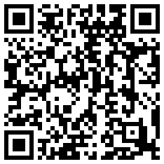
The Reports page is the starting point for every report in the app. From here you can build a mailing list and print address labels, see how many magazines and leaflets went out, follow giving totals, review membership changes, plan services and check stock. This chapter walks through each report in turn.
Who can use this: Everyone who signs in can open the Reports page and every report on it. What you see inside each report depends on your account. National / Admin sees every church. Regional, Admin Assistant and Local see only the churches listed in their account’s church access. If your account has no churches set, most reports show a short message instead of figures. Ask an administrator to add the churches you are responsible for.

The Reports page
Click Reports in the left menu. The reports are shown as cards, grouped by topic. Each card has its name and a one-line description of what is behind it.
Group | Cards
Membership | Membership Changes, Pilgrimage Applications
Attendance | Attendance Report, Scheduled Services
Events | Retreats and meal events (only for National / Admin and Regional)
Distribution & Mailing | Glory Magazine Distribution, Leaflet Distribution, Mailing Reports & Labels
Inventory & Orders | Regional Inventory, Order Report
Finance | Financial Reports

How to open a report
- Click Reports in the left menu.
- Click the card of the report you want.
Tip: To keep the Reports page open, hold Cmd (Mac) or Ctrl (Windows) while you click a card. The report opens in a new browser tab.
The Glory Magazine Distribution card opens a page titled Miracle Magazine Distribution. They are the same report.
The Retreats and meal events card opens the HQ Volunteers page on its reports tab, described in chapter 10. The Pilgrimage Applications card is covered in chapter 9.
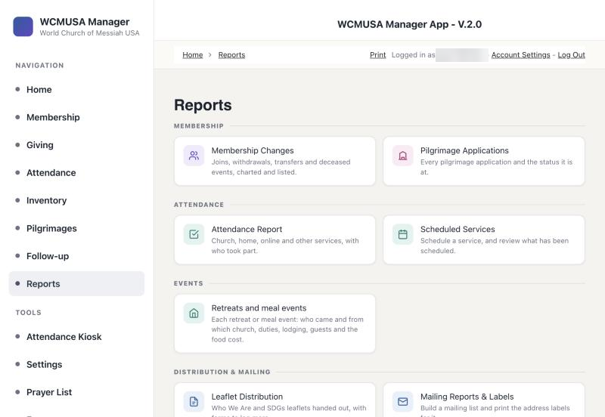
The Reports page with its grouped cards

Mailing Reports & Labels
This report builds the list of members who can receive the magazine by post: Miracle in English or Milagre in Portuguese. From that list you can export a spreadsheet, print address labels, and record who was sent which issue, so that nobody gets the same issue twice.
National / Admin sees members of every church. Everyone else sees members of their own churches only.
The page has these parts, from top to bottom:
- The mailing bar. Choose the Mailing (Miracle (English) or Milagre (Portuguese)) and type the Issue, for example “Oct 2026”. Next to it, a stock line shows how many copies are in stock at your regional hub, how many this run needs, and how many will be left. If there are not enough, it shows how many you are short, in red.
- Summary cards. How many members are selected, how many have a complete address, how many cannot be posted, how many are mailable, and how many have already received this issue.
- Filters. Status, Church, Address, Age and Language.
- The export bar. How many people will be exported, with the buttons Export CSV, Export Excel, Labels — Avery 5160 and Labels — Avery 5162.
- The logging bar. Records the issue as sent, with the Log send for these N button.
- The table. One row per member, grouped by status and church, with the columns Name, Language, Address, City / State / Zip, Age, Last sent and Mailing.

Who receives the magazine by post
- The address must be complete: street, city, state and zip.
- The person must be over 12, or have no date of birth recorded. An unknown age counts as mailable and is marked as assumed.
- Members whose status is excluded, deceased, transferred, withdrawn or removed never get post. They stay in the table, greyed out and in italics, but are left out of exports, labels and logging. Inactive members still get post.
- Each person gets one edition, chosen by their primary language. If no primary language is set, the app uses their first second language, and then English.

How to post an issue to everyone who can receive it
- In Mailing, choose Miracle (English) or Milagre (Portuguese).
- In Issue, type the issue, for example “Oct 2026”.
- If you need to, set Language and Church.
- Check the number that will be exported and the stock line.
- Click Labels — Avery 5160 (30 labels per sheet) or Labels — Avery 5162 (14 labels per sheet). A new window opens with the label sheets.
- Click Print. Print at 100% or actual size, so the labels line up.
- Back on the report, check the date and the method (USPS Mail or By Hand) in the logging bar.
- Click Log send for these N. A confirmation shows how many copies come off which church.
- Click OK. When it finishes, the message reads “Logged N. Stock updated for N church(es).”
Important: Always type the Issue before you print or log. The app uses the issue name to know who has already received it. With no issue typed, nobody is held back as already received.
Tip: If the label window does not open, your browser blocked it. Allow pop-ups for this site and click the label button again.

How to export the list as a spreadsheet
- Set the filters you need.
- Click Export CSV or Export Excel. The file downloads to your computer.

How to record one person who already got a copy
- Find the person in the table.
- In the Last sent column, click + log Miracle (or + log Milagre).
- Confirm. The cell changes to “has this issue”.

How to include an excluded person for one run
Sometimes a person who is normally left out, such as a transferred member, has asked to keep receiving the magazine.
- Find the greyed row.
- Tick send anyway above their name.
This lasts only until you reload the page. It does not change the member’s record.

How to correct someone’s language
- Point at the person’s row and click edit in the Language cell.
- Choose the primary language and tick any second languages.
- Click Save.

Where the copies come from
When you log a send, the copies come off the regional hub’s stock for each member, not off the member’s own church. To take them from one particular church instead, choose it in the from list in the logging bar. Stock never goes below zero. If a church is short, the confirmation warns you before anything is saved. See chapter 8 for the regional hubs.
If the stock line looks wrong, click recount from purchases. The app works out the count from what was received and sent, and corrects the hub’s number.

Magazine received (on a member’s page)
You can also record a single copy for one person, for example a magazine handed over at church. Open the member, and use the Magazine received box under the contact details.

How to record a copy for one member
- Choose the publication.
- Type the issue, for example “Oct 2026”.
- Check the date and choose USPS Mail or By Hand.
- Enter the number of copies.
- Click Log it. The message reads “Logged.”
The entry goes into the same record the Mailing list uses, so this person will not get a label for that issue. The history below the box shows each entry with Edit and Delete buttons. Logging takes the copies off stock, editing moves only the difference, and deleting puts the copies back.

Miracle Magazine Distribution
Open it with the Glory Magazine Distribution card. This report shows how many Miracle and Milagre copies went out each month, by hand or by post, and to whom.
- Cards at the top: copies sent of all time, Miracle (English), Milagre (Portuguese), and the number of log entries.
- A monthly table with the columns Month, Miracle, Milagre, By hand, USPS and Total, and a total row at the bottom.
- Stock Transfer from HQ, below the panel: the total quantity of each item moved to each church, with a date filter.
The report counts copies, not entries. One hand-out of five magazines counts as five.

How to see who received copies in a month
- Click the month in the table. The list of members opens, with the publication, issue, date, method and copies.
- Click Show more months to go further back. Each click adds 12 months.
- To save the figures, click Export CSV.

Leaflet Distribution
This page records how many Who We Are and SDGs leaflets each church handed out. It has a form and a table for each leaflet.
- Add Who We Are Distribution: Distribution Date, Quantity, Notes, Local Church and Region.
- Add SDGs Leaflet Distribution: Distribution Date, Quantity English, Quantity Portuguese, Notes and Local Church.
The Who We Are Distributions table shows the current calendar year only. Both tables have a search box and filters.

How to record leaflets handed out
- Fill in the form for the leaflet you handed out.
- Click Submit.
- A message at the bottom of the screen confirms that the stock was updated, for example “Inventory updated: 200 Who We Are Leaflet off Orlando.”
Saving a distribution takes the leaflets off stock. They come off your church’s own shelf if it holds any, otherwise off your regional hub. If there were not enough, the message is red and says how many were short. Editing a quantity moves only the difference, and deleting a record puts the leaflets back.
Important: Change leaflet quantities only with the Edit and Delete links in these tables, not with Bulk actions. Only the forms and links on this page update the stock.

Financial Reports
Open it with the Financial Reports card. This page brings together the giving totals for your churches.
- Global Giving Summary: quick totals for a month, a quarter and a year, compared with the period before and with last year.
- Giving by Region: a bar chart.
- Donations for Hokokusho Report: a table of amounts by category and Hokokusho month.
- All Income by Date: a table of amounts by category and month.
- Count & Deposit Reports: a link to the list of count and deposit reports with their category amounts.
The two tables have the filter buttons National, WC, NE and SE, for the whole country or one region.
Local accounts do not see the Global Giving Summary or the Giving by Region chart on this page.
How the numbers are counted: The giving reports total every donation record for the churches in scope. This includes donations still waiting in Imported — Pending Review, as well as purchase and trip payments such as sacred objects and pilgrimage. Use the Category filter to look at one kind of giving.
A donation is counted for the church where it was given, not the giver’s home church. If a gift appears under the wrong church or region, check its Local Church. Chapter 5 explains donations and deposits in full.

How to use the Global Giving Summary
- Choose the Year.
- Choose the Month, or leave All months.
- If you look after more than one church, choose the Church.
- Choose a Category, or leave All categories.
- Click Apply.
- Switch between the tabs Summary and YTD vs Prior Year.
The grey Scope line tells you which churches are included. Each card has a coloured edge: green when giving went up, red when it went down, grey when it stayed the same. Amounts are rounded to whole dollars.
The YTD vs Prior Year tab compares this year so far with the same months of last year, and shows a month-by-month breakdown.

Membership Changes
This report lists every join, transfer, withdrawal, exclusion and passing.
- A chart of changes by month and type.
- A table with the columns Change Type, Name, Change Date, Notes, Member, Local Church and Region, with Edit and Details links.
- The Add Membership Change form.
The change types include New Member, Transfer In, Transfer Out, Withdrawn, Member Excluded, Deceased and Reinstated.

How to record a membership change
- In Add Membership Change, choose the Member.
- Enter the Change Date and choose the Change Type.
- Add a Reason and Notes if needed.
- For a transfer, fill in To Church or To Country.
- Submit the form.
Tip: When a member is saved as deceased with a Date of Passing, the app corrects the date of the matching Deceased change to match.

Attendance Report
This page holds the attendance reports for church services, home services, home gatherings, online meetings and other activities. Each table shows the current calendar year. Chapter 4 explains how to fill in an attendance report.
The tables on this page are Church Service Reports, Home Service Reports, Home Gathering or Other Activities, Online Meetings or Studies, Other Activities and Scheduled Service Reports.
Online Meetings or Studies lists the online meetings and study groups your churches reported, with the counts of members, friends and first-time visitors who joined online.

Scheduled Services
This page lists services planned ahead, with the officiant, language and expected numbers.

How to schedule a service
- In Schedule a Service, choose the Service Name.
- Enter the Officiant.
- Choose the Service Type: Church Service, Church Service (Non Physical Church) or Member’s Home Service.
- Enter the Service Date and Service Time.
- Choose the Region and Local Church.
- Choose the Service Location: Church, Member’s Home or Rental Location.
- Choose the Language.
- Enter Projected Participants (at Church) and Projected Participants (Online).
- Add any Observations.
- Submit the form. The message reads “Service scheduled.”
The Scheduled Services table lists the newest services first. You can search it, filter it and export it. The chart Scheduled Service Reports shows the projected participants.

Regional Inventory and Order Report
Regional Inventory is a read-only summary of the stock held at each church and the purchases behind those counts. Order Report lists members’ orders for sacred objects in three tables: Pending Orders, Concluded Orders and Cancelled Orders. Both are explained in chapter 8.

Charts on the Home page
The Home page shows charts for your churches. Those that belong to this chapter are:
- Giving by Church and the Global Giving Summary.
- Membership by Status and Membership Changes by Type.
- Attendance by Activity.
- Pilgrimage Applications by Status.
- Inventory On Hand by Church.
- Who We Are Leaflets by Church and SDGs Leaflets by Church.
The giving figures on the Home page are counted in the same way as on Financial Reports.
Charts on the Home page

Quick reference
Task | Where | Who
Open any report | Reports in the left menu, then a card | Everyone
Print magazine address labels | Mailing Reports & Labels, Labels — Avery 5160 or 5162 | Everyone, for their churches
Record an issue as sent | Mailing Reports & Labels, Log send for these N | Everyone, for their churches
Record one copy for one member | Member page, Magazine received | Everyone, for their churches
See copies sent per month | Glory Magazine Distribution | Everyone, for their churches
Record leaflets handed out | Leaflet Distribution | Everyone, for their churches
See giving totals | Financial Reports | Everyone, for their churches; the summary and region chart are not shown to Local
Record a membership change | Membership Changes | Everyone, for their churches
Schedule a service | Scheduled Services | Everyone, for their churches

8. Inventory
Videos for this chapter
- Moving stock between hubs, step by step 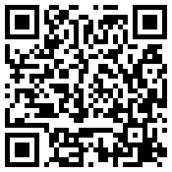
- Recording a delivery, step by step 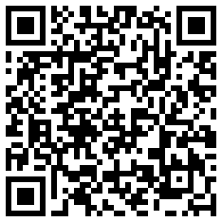
The Inventory part of the app keeps count of the magazines, leaflets, Prayer Books, Bibles and other items each church holds. Here you record deliveries from the supplier, move stock from one church to another, check counts against the records, and keep the list of items up to date. Two reports, Regional Inventory and Order Report, give you a summary of stock and of members’ orders.
Who can use this: Everyone who signs in can open the Inventory page. National / Admin sees the stock of every church. Regional, Admin Assistant and Local see the stock, purchases and orders of their own churches only. The list of items, Sacred Objects Catalogs, is the same for everyone.

How stock is kept

The four regional hubs
Magazines and leaflets are not kept at every church. They are kept at four regional hubs, and the churches nearby are served from there:
Hub | Also serves
Orlando (Southeast) | Atlanta, Dania Beach, Hispanic America - Peru
New Jersey (Northeast) | New England, Washington D.C.
Los Angeles (West Coast) | Chicago, Northern California, HQ
Hawaii | Hawaii keeps and uses its own stock
When copies are handed out or posted, the app takes them from the church’s own shelf if it holds any. If it does not, the app takes them from the church in the same region that holds the most, which is normally the hub.

One count per item and church
Each church has one On-Hand count for each item. These actions change it for you:
- Saving a purchase as Received or Paid adds copies.
- Move in Move stock between churches takes copies off one church and adds them to another.
- Logging a magazine as sent, on the Mailing list or on a member’s page, takes copies off.
- Saving a Who We Are or SDGs leaflet distribution takes copies off.
- Typing a number into a count box sets the count directly.
Stock never goes below zero.

The Inventory page
Click Inventory in the left menu. The page has these parts:
- Move stock between churches, at the top.
- Add Inventory Purchase For Churches, a form for deliveries from the supplier.
- Sacred Objects Catalogs, the list of items, with name, cost per unit, minimum required, description and image. It has a search box and Add filters.
- Church Inventories, the count of each item at each church, with an Edit link.
- Inventory Purchases, every purchase with its date, quantity and status.
- Customer Orders, members’ orders for sacred objects.
- Add Church Inventory, a form to give a church a count for an item.
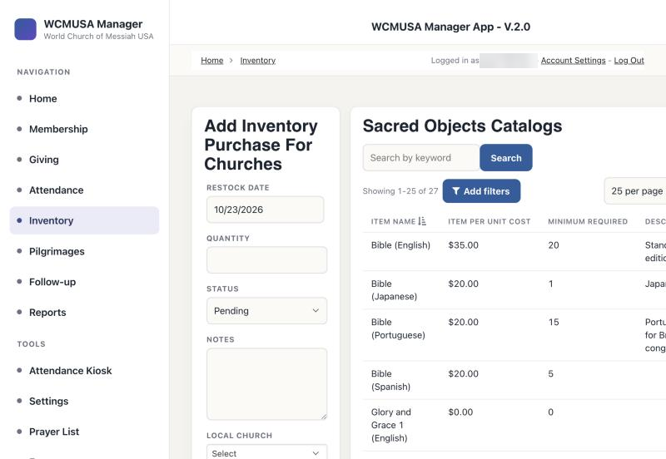
The Inventory page

Move stock between churches
Use this panel to move items from one church to another, for example from the Los Angeles hub to Chicago. Both counts change at once, and the move is recorded.

How to move stock
- Choose the Item.
- In From, choose the church that holds the stock. Each church is shown with its count.
- In To, choose the receiving church.
- Type the number in how many.
- Check the date.
- Click Move. The message reads “Moved N to [church] on [date].”
The From list shows only the churches you look after. The To list shows every church. If no church holds the item, the list reads “nobody holds any” in red.
Below the controls, a line shows the total on hand and the count at each church. Transfers of [item] lists the last 10 moves of the selected item.
Important: Always move stock with the Move button. Changing or deleting a move in a stock transfer table does not move the stock back.

How to check counts against the records
- Choose the Item.
- Click Show the count for every church.
- Read the table. For each church it shows what was bought, moved in, moved out, handed out by hand and by post, the number it Should hold, and the number it Actually holds.
- Rows that disagree are shaded red and show the difference.
- To correct a count, type the right number in Actually holds and press Enter.
“not tracked” means the church only has a starting count that someone typed in, with no purchases, moves or hand-outs on record. A red note lists any church that handed out more than it was recorded as receiving. To fix it, record the move that brought the stock there.
Hand-outs are counted only for the two magazines and the three leaflets.

How to see the whole stock list
- Click Show the whole stock list.
- Filter by Church and Item. In Show, choose Everything, Only where there is stock or Only below the reorder level. You can also type in the search box.
- To change a count, type the new number in its box.
- Click Hide the stock list to close it.
Items below their reorder level are highlighted and marked “low”. The Total shown row at the bottom adds up the list.

The list of items (catalog)
The Sacred Objects Catalogs table lists every item the app keeps count of. You add and change items in the Move stock between churches panel.

How to add an item
- Click + Add an item to the list.
- Type the name of the new item.
- Fill in reorder below and unit cost, and a note if you like.
- Click Add.
- To give a church a shelf for the new item, move stock into that church.

How to change an item
- Choose the item in Item.
- Click edit next to it.
- Change the name, reorder level, unit cost or note.
- Click Save.
An item can be deleted with Delete this item only if nothing has ever used it. If it has purchases, moves, mailings or stock, the app refuses. Rename it instead.

Purchases arriving from the supplier
Record each delivery from the supplier as a purchase. When a purchase is saved as received, the app adds it to the church’s count for you.

How to record a delivery
- On the Inventory page, go to Add Inventory Purchase For Churches.
- Choose the Sacred Objects Catalog item and the Local Church that received it.
- Enter the Quantity and Restock Date.
- Set Status to Received, or Paid.
- Add any Notes.
- Submit the form. A green message confirms the new count, for example “Added 6000 × Who We Are Leaflet to NEW JERSEY. On hand: 6000.”
The Status choices Pending and Submitted mean the order has not arrived yet. A purchase saved with one of these does not change the count. The Inventory Purchases table lists every purchase with its status.
Tip: Choose Received only when the goods are physically there. The stock is added the moment you save.
If a red message says the purchase was saved but the stock count was not updated, set the count by hand in the stock list.

Leaflet distributions
When you record Who We Are or SDGs leaflets handed out on the Leaflet Distribution report, the app takes them off stock. They come off your church’s own shelf if it holds any, otherwise off your regional hub. Chapter 7 explains the forms.

Regional Inventory
Open it from Reports with the Regional Inventory card. It is a read-only summary:
- Church Inventories: the count of each item at each church.
- Inventory Purchases: quantities bought, by month.
To correct a number, use the Inventory page, not this report.

Order Report
Open it from Reports with the Order Report card. It lists members’ orders for sacred objects in three tables, newest first:
- Pending Orders
- Concluded Orders, the orders that have shipped
- Cancelled Orders
Each order shows the date, member, item, quantity, unit price, order total, amount paid, balance, Payment Status (Unpaid, Partial or Paid in Full) and church.
Orders are created on the member’s Purchases tab. Payments are recorded on the donation form, as explained in chapter 5.

How to mark an order as delivered
- Click Edit on the order.
- Set Order Status to Shipped.
- If you use them, tick Received and fill in Received Date.
- Submit the form. The order moves to Concluded Orders.

Quick reference
Task | Where | Who
Move stock to another church | Inventory, Move stock between churches | Everyone, from their own churches
Check counts against the records | Inventory, Show the count for every church | Everyone, for their churches
Correct a count | Inventory, Show the whole stock list | Everyone, for their churches
Add or rename an item | Inventory, + Add an item to the list or edit | Everyone
Record a supplier purchase | Inventory, Add Inventory Purchase For Churches | Everyone, for their churches
See a stock summary | Reports, Regional Inventory | Everyone, for their churches
Mark an order delivered | Reports, Order Report, Edit | Everyone, for their churches

9. Pilgrimages
Videos for this chapter
- The pilgrimage roster, step by step 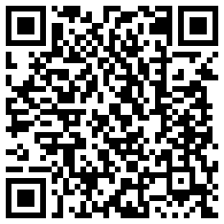
- Editing an application, step by step 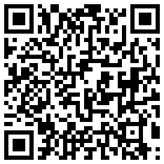
- Flights and the Japan list, step by step 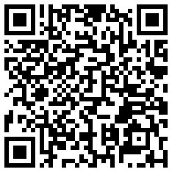
The Pilgrimages page is the one place to run a pilgrimage. Here you see every trip, who is going, who has paid, their flights and hotel rooms, the day-by-day schedule, and the printouts and lists that Headquarters in Japan asks for. Pilgrims register themselves on a public form (see chapter 11); everything they send arrives here.
Who can use this: National / Admin — everything, for every church. Regional — the pilgrims of their own churches only: change status, payment, certainty and hotel room, link pilgrims to members and payments, view and print. Regional never sees passports, medical details, emergency contacts or birth dates. Local and Admin Assistant — the roster is not available to these accounts.

The Pilgrimages page
Open Pilgrimages in the left menu (or the Pilgrimages tile on the Home page). At the top you see:
- Upcoming pilgrimages — one button per trip, with its title, its status and the number of pilgrims. The selected trip is highlighted. When you open the page, the first upcoming trip is already selected.
- Archived pilgrimages — a fold-out list of completed trips, with the number of trips in brackets.
- Three tabs: Roster, Schedule and Flights.
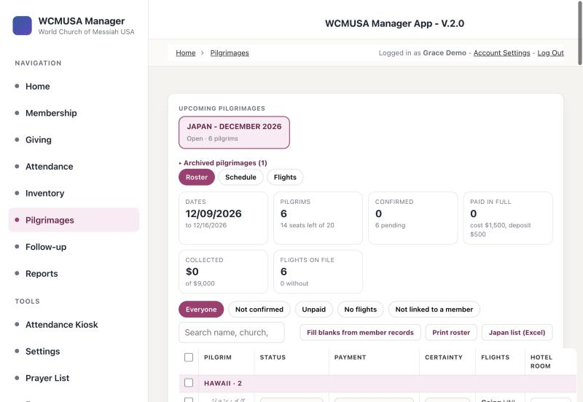
The Pilgrimages page with an upcoming trip selected

Trips: open, completed and archived
A trip is created with the form Add Pilgrimage Trip further down the Pilgrimages page. You give it a Trip Title, Country, Start Date, End Date, Status, Cost, Deposit Amount, Capacity and an optional Poster (shown on the public registration page). Existing trips are listed in the Manage trips table, where each trip has Edit, a details button (the eye) and Delete.
What each setting does:
- Status Open — only trips with the status Open appear on the public registration form.
- Cost and Deposit Amount — the app uses them to work out each pilgrim’s payment status and how much is still owed. With no cost, the roster says “no cost set on the trip”.
- Capacity — shown on the roster as “seats left”. The app does not stop registrations when the trip is full, so keep an eye on it.
- Poster — shown whole beside the public registration form.
When a trip’s End Date has passed, the app marks it Completed by itself. Completed trips move under Archived pilgrimages. Opening one shows the note “This pilgrimage is completed. Its registrations are archived and kept for the record.” You can still view, print and export everything on an archived trip.

How to create a trip
- On the Pilgrimages page, scroll down to Add Pilgrimage Trip.
- Fill in Trip Title, Country, Start Date and End Date.
- Enter the Cost, the Deposit Amount and the Capacity.
- If you have a poster, add it under Poster (shown on the public registration page).
- Set Status to Open when you are ready for people to register.
- Click Submit.

How to open an archived trip
- At the top of the Pilgrimages page, click Archived pilgrimages.
- Click the trip you want.

The Roster tab
The Roster tab shows everyone registered for the selected trip. It opens by default.
Summary cards across the top show the trip dates, the number of pilgrims and seats left, how many are confirmed and pending, how many have paid in full, the money collected so far, and how many have flights on file.
Filters. Click one of the chips to narrow the list: Everyone, Not confirmed, Unpaid, No flights or Not linked to a member. Use the search box to find a pilgrim by name, church, email or phone.
How the list is arranged. Pilgrims are grouped by church, with the number of pilgrims beside each church name. Pilgrims who are not yet placed in a church are listed under “Not placed in a church yet”. Inside each church, pilgrims are in order of their 立場 position (HQ head first, members last), then the oldest first.
Each row shows:
- Pilgrim — the name in katakana (small, above the name, when it has been entered), the name, age and phone, and the buttons View and (National / Admin) Delete. A pilgrim who is not linked to a member has a red “not linked” tag and a Link to member button.
- Status — Confirmed or Pending.
- Payment — Unpaid, Paid Deposit, Paid Deposit & Some or Paid in Full, with the amount paid and the amount still due underneath.
- Certainty — how sure the pilgrim is to attend: 100%, 50% or 25%.
- Flights — a short summary of the going and return journeys, or “Not booked yet”.
- Hotel room — a small box for the room number.
On a narrow screen, the Certainty, Flights and Hotel room columns are hidden.
Tip: If you reload the page in your browser, the roster may say you are not signed in, or stay empty. This happens when the page asks for the roster before your sign-in is ready. Click another item in the left menu, then click Pilgrimages again. You can also wait a moment and click it again.
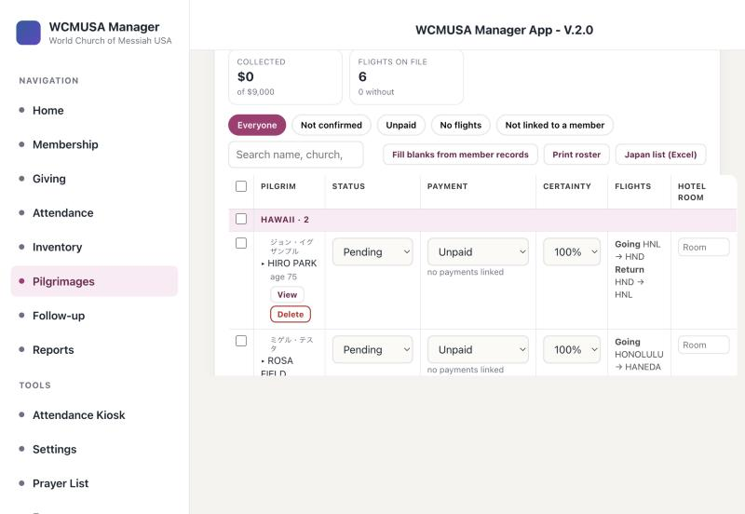
The roster of a trip, grouped by church

How to change one pilgrim’s status, payment, certainty or room
- Find the pilgrim on the roster.
- Choose a new value in the Status, Payment or Certainty drop-down. It saves at once.
- To set the room, type it in the Hotel room box and click anywhere outside the box.
Tip: When you change Payment to anything other than Unpaid, the app fills in today’s date as the payment date, if there was none.

How to see a pilgrim’s details
- Click the pilgrim’s name. The row opens.
- Read the boxes Contact, Stay, Payments and Flights. Flights show each leg with layover times and whether the ticket is bought.
- National / Admin also see the boxes Passport · National only, Medical · National only and Emergency · travel, and the buttons View application and Delete registration.
If a connecting flight leaves before the previous flight lands, the app warns: “Connection leaves before the previous flight lands – check the times”.
Important: Passports, medical details, emergency contacts and birth dates are for National / Admin only. Regional accounts never receive them; they see the pilgrim’s age instead of the birth date.

Changing several pilgrims at once
You can set the status, payment or certainty of many pilgrims in one go.

How to change several pilgrims at once
- Tick the box at the left of each pilgrim you want. Tick the box on a church heading to select everyone in that church, or the box in the table heading to select everyone shown.
- A bar appears at the top saying how many are selected.
- Choose a new value in Status, Payment and/or Certainty. Leave the others on “no change”.
- Click Apply to (the button shows the number of pilgrims).
- Confirm the question.
- Read the result: how many were updated, and the names of any that were not changed and why. Pilgrims that were not changed stay ticked.
- Click Clear to untick everyone.
Hotel rooms and member links cannot be changed this way. You can change up to 200 pilgrims at a time. If some ticked pilgrims are hidden by the filter, the bar tells you.

Viewing and printing an application
Every registration can be opened as a complete, printable application.

How to view and print an application
- On the roster, click View on the pilgrim’s row (or View application in the opened row).
- The application opens: the name in katakana and in letters, the trip, status, payment, certainty, application number, date applied and church, then numbered sections — Applicant, Pilgrimage and payment, Japan experience, Accommodation and Flights.
- Click Print / Save as PDF.
- In the print window, choose your printer, or choose Save as PDF to keep a file.
- Click Close when you are done.
The printout is Letter size, upright. Each page shows the applicant’s name, the page number and the trip title at the bottom, and a section is never split across two pages. It ends with a signature line and an “Office use” box.
National / Admin also see and print the sections Passport and travel, Health, Emergency contact and Acknowledgements, marked “National office only”. Regional see a note that these details are held by the National office.
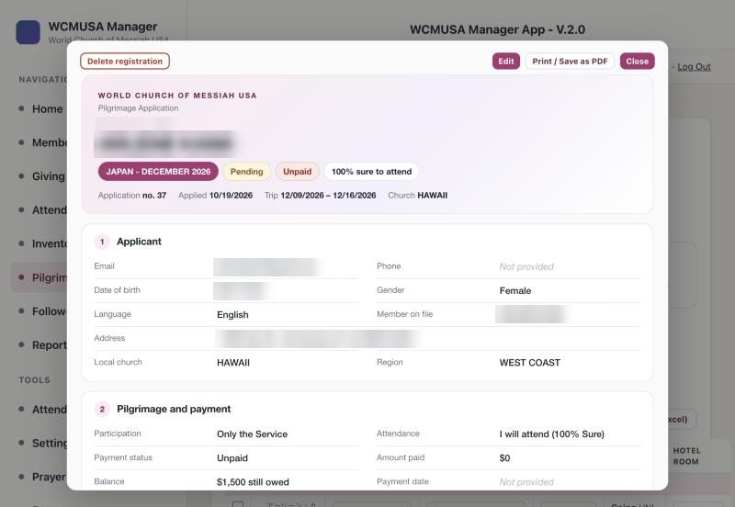
An application opened for viewing

Editing an application
Who can use this: National / Admin only.
You can change every answer on a registration, add the name in katakana, set the pilgrim’s position, and enter or correct flights.

How to edit an application
- Open the application with View.
- Click Edit. The form “Edit application” opens with all the answers.
- Change what you need. The sections are Applicant, Address, Pilgrimage and payment, Japan, Stay, Passport and travel, Health, Emergency contact, Acknowledgements and Flights.
- Click Save changes (or Cancel to leave without saving).
- A note confirms “Saved” with the pilgrim’s name. If some empty answers were filled from the member record, the note lists them.
Good to know:
- First name and Last name are required.
- フリガナ is the name in katakana, as Japan should read it (for example アナ・マリア・キスペ). It appears above the name on the roster, on the printouts and on the Japan list.
- 立場 is the pilgrim’s position, for the list to Japan: 本部長 HQ head, 副本部長 Deputy HQ head, 理事 Director, 教区長 District head, 評議員 Councilor, 教会長 Church minister, 信徒 Member. A blank position counts as 信徒 Member. The position sets the order on the roster, the printouts and the Japan list.
- Changing Local church also changes the region to that church’s region.
- Changing Trip moves the registration to another trip.
- If the pilgrim is linked to a member, any answer you leave empty is filled from the member’s record when you save.
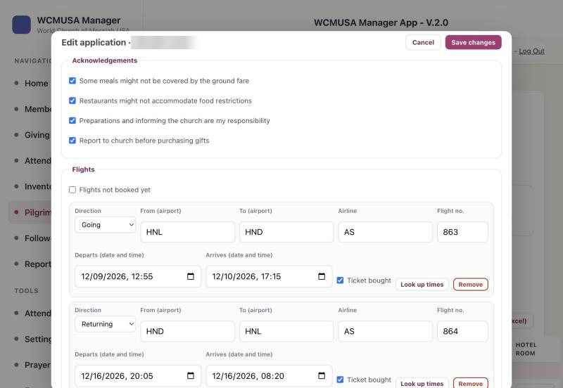
The Edit application form, with Cancel and Save changes at the top

Flights in the editor
Each flight leg is a card with Direction (Going or Returning), From (airport), To (airport), Airline, Flight no., Departs (date and time), Arrives (date and time), a Ticket bought tick, and the buttons Look up times and Remove.
- + Going flight and + Returning flight add a leg. A new leg starts at the airport where the previous leg landed.
- A leg without Ticket bought is tentative. It is marked as tentative on the Flights tab, the printouts and the Japan list.
- Flights not booked yet is ticked when the pilgrim has no flights yet. Adding a leg removes the tick.
- When you save, the flights in the editor replace all of the pilgrim’s earlier flight legs.

How to fill in flight times automatically
- In the flight card, type the Airline (a name such as United or JAL, or the two-letter code) and the Flight no.
- Type the departure date in Departs (date and time). The time can be anything.
- Click Look up times.
- The airports and the scheduled local times are filled in, with a green note saying which flight was found.
- Check the result, then click Save changes.
If the flight is not found, a red note explains why and offers Search Google instead. Click it to look the flight up on Google and type the times yourself. If a flight number makes several stops that day, the note asks you to check it is the right one.
Tip: Typing the airline code with the number, such as LA 801, always works.
Flight cards with Ticket bought, Look up times and Remove

Linking a pilgrim to a member
Registrations from the public form are not linked to a member record. Linking a pilgrim files them under the member’s church and region, lets you attach their payments, and fills their empty answers from the member record.

How to link a pilgrim to a member
- On the roster, find a pilgrim with the red “not linked” tag. Tip: use the Not linked to a member chip.
- Click Link to member.
- The search box is already filled with the surname. Type at least two letters to change it.
- Click the right person (the name and church are shown).
- A note confirms the link and lists the answers filled from the member record.
Regional can only link to members of their own churches.

How to fill blanks from member records
Who can use this: National / Admin only.
- Select the trip on the Roster tab.
- Click Fill blanks from member records.
- For every linked pilgrim on the trip, the app fills empty answers — name, email, phone, birth date, gender, language, church, region and address — from the member record. It never changes an answer that is already filled in.
- A note says how many applications were filled.

Linking payments
Pilgrimage payments are recorded first as donations on the Giving page, with a pilgrimage category. You then link them to the registration. The amount paid is the total of the linked donations, and the payment status is worked out from the trip’s cost and deposit:
- Nothing paid — Unpaid.
- At least the deposit — Paid Deposit.
- More than the deposit — Paid Deposit & Some.
- The full cost — Paid in Full.

How to link a payment
- Make sure the pilgrim is linked to a member.
- On the roster, click the pilgrim’s name to open the row.
- In the Payments box, click + Link a payment.
- The window lists that member’s pilgrimage donations. Click Link beside the right one. If it is linked to another registration, the button says Move here.
- The roster reloads with the new amount and payment status.
To remove a link, click Unlink. The donation itself is kept.
Tip: You can also link a payment from the Giving page: when a donation has a pilgrimage category, choose the registration under Apply to pilgrimage registration. See chapter 5.

Deleting a registration
Who can use this: National / Admin only.

How to delete a registration
- Click Delete on the pilgrim’s row (or Delete registration in the opened row or the application view).
- Read the question. Deleting also removes the pilgrim’s flight legs and cannot be undone. Donations linked to the registration are kept.
- Confirm.

Printing the roster

How to print the roster
- On the Roster tab, choose the filter chip and search you want. Only the pilgrims shown are printed.
- Click Print roster.
- In the print window, choose your printer or Save as PDF.
The roster prints on Letter paper, sideways (landscape), as one list of all pilgrims — not split by church — in order of position, then the oldest first. Each pilgrim shows the name in katakana and letters, position and church, age and phone, language, status and payment, how sure they are to attend, every flight leg with local times (tickets not bought are marked in red), and where they stay. Passports and medical details are never printed on the roster.

The Schedule tab
The Schedule tab is the trip’s day-by-day itinerary. Activities are grouped by day, each with its time, type, details, address, transportation, phone, notes and link. Everyone who can open the roster can read and print it; only National / Admin can add, change or delete activities.

How to add an activity
- Click the Schedule tab.
- Click + Add an activity.
- Fill in Date, Time and Activity (for example “Airport: Arrival”, “Service” or “Free Time”).
- Add Details, Address, Transportation, Phone, Important observations and a Link if needed.
- Click Save.
To change an activity, click Edit beside it. To remove it, click Edit, then Delete, and confirm.

How to print the itinerary
- Click the Schedule tab.
- Click Print itinerary. It prints upright, day by day.

The Flights tab
The Flights tab shows every flight leg of every pilgrim on the trip. Flights are entered on the public form or in the application editor; you cannot change them on this tab.
- Chips: All flights, Purchased and Tentative (not purchased), each with a count. A search box narrows the list.
- Flights shared by several pilgrims: two columns, To Japan and Home from Japan. Each card is a flight that two or more pilgrims are on, in time order, with the flight number, route, times, the number of pilgrims and their names. Use it to see who to meet at which airport.
- The table: grouped by church, one line per flight leg: pilgrim, leg (for example “Going 1”), flight, from, departs, to, arrives and ticket. Purchased tickets are green; Tentative tickets are amber and the row is shaded. Under the table, the app lists the pilgrims with no flights yet.
Tip: The filter chip you chose on the Roster tab also applies here. If the Flights tab looks short, go back to the Roster tab and click Everyone.
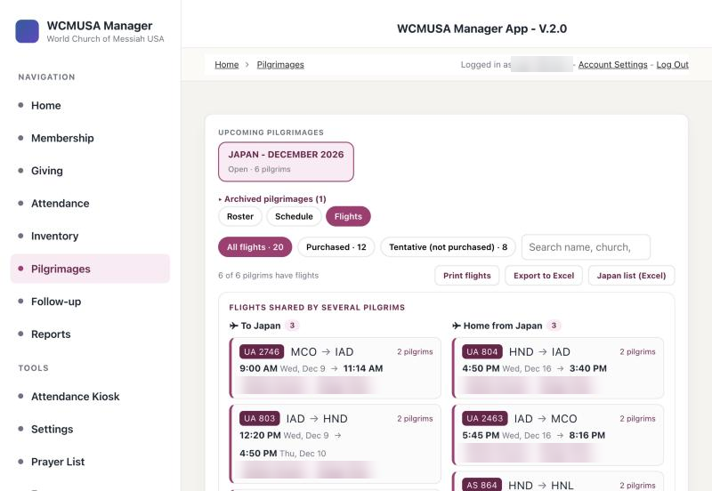
The Flights tab with flights shared by several pilgrims

How to print the flights
- On the Flights tab, choose All flights, Purchased or Tentative (not purchased).
- Click Print flights.
- Choose your printer or Save as PDF.
It prints sideways on Letter paper, as one list of all pilgrims in order of position then age, one line per leg, with tentative tickets marked. Then come the flights shared by several pilgrims (To Japan and Home from Japan), and, when showing all flights, the pilgrims with no flights yet.

How to export the flights to Excel
- On the Flights tab, choose the chip you want.
- Click Export to Excel.
- A file named after the trip (for example “Trip - flights.csv”) downloads. Open it in Excel.
The file has one line per flight leg, with church, pilgrim, phone, email, direction, airline, flight, airports, dates and times, ticket, status, attendance and stay. With All flights, pilgrims without flights are added at the end.
Important: The exported file contains email addresses and phone numbers. Keep it private and delete it when you no longer need it.

The Japan list (Excel)
Who can use this: National / Admin only. The list contains allergies and health conditions.
Before a service, Headquarters in Japan asks for a list of who is coming, in Japanese and in their own layout. The Japan list (Excel) button builds it for you. It is on the Roster tab and on the Flights tab.
The workbook has two sheets:
- 参拝者名簿 — who is coming: country, name in katakana and in letters, gender, age, 立場 position, church, language, number of visits, allergies, health conditions and notes (ticket status, 50% or 25% certainty, service only, home stay, visa needed).
- フライト情報 — for each pilgrim, the flight arriving in Japan and the flight leaving Japan, with the full route, local times and whether the ticket is bought.
Pilgrims are in the order 本部長, 副本部長, 理事, 教区長, 評議員, 教会長, 信徒, and members by age, oldest first. Three blank rows are added at the end of each sheet. The list always includes everyone on the trip, whatever filter is chosen on the roster.

How to make the Japan list
- Before you start, make sure every pilgrim has フリガナ and 立場 filled in (see Editing an application). Otherwise the readings are blank and everyone counts as 信徒.
- Select the trip.
- Click Japan list (Excel).
- A box asks for the event name as it should appear in the title. It is already filled in from the trip date, for example “2026年 クリスマス祝典”. Correct it if needed.
- Click OK. The button shows “Building…” for a moment.
- The Excel file downloads. Send it to Headquarters in Japan.
Tip: The first time, the button needs an internet connection to prepare Excel.

Quick reference
Task | Where | Who
Create or edit a trip | Pilgrimages → Add Pilgrimage Trip / Manage trips | National / Admin
Open a completed trip | Pilgrimages → Archived pilgrimages | National / Admin, Regional
Change status, payment, certainty, room | Roster tab, drop-downs on the row | National / Admin, Regional
Change several pilgrims at once | Roster tab, tick rows → Apply to | National / Admin, Regional
View or print an application | View → Print / Save as PDF | National / Admin, Regional
Edit an application, katakana, position, flights | View → Edit → Save changes | National / Admin
Link a pilgrim to a member | Link to member | National / Admin, Regional
Fill empty answers from member records | Fill blanks from member records | National / Admin
Link a payment | Open the row → + Link a payment | National / Admin, Regional
Delete a registration | Delete | National / Admin
Print the roster | Print roster | National / Admin, Regional
Add or change the itinerary | Schedule → + Add an activity | National / Admin
Print flights or export them | Flights → Print flights / Export to Excel | National / Admin, Regional
List for Headquarters in Japan | Japan list (Excel) | National / Admin

10. Events: HQ volunteers, retreats and meal events
Videos for this chapter
- Events and volunteers, step by step 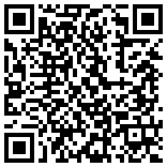
The Events page runs two kinds of events. A retreat is a training period at Headquarters: people apply to serve as volunteers, you approve them, and the app plans who does which duty each day, where everyone sleeps, and what the kitchen cooks and buys. A meal event is a single meal or a short event — a picnic, a lunch, a fellowship meal — with only the kitchen and a report.
Who can use this: National / Admin — everything. Regional — the applicants from their own churches (read, record the endorsement, write notes), the daily board to read, and meal events for their own churches. Health notes and emergency contacts are never shown to Regional. Local and Admin Assistant — Events is not available to these accounts.

Opening Events
Click Events in the left menu, under Tools. The path at the top of the page reads HQ Volunteers. The first screen asks “What would you like to open?” and shows two boxes:
- Retreats — training periods at Headquarters, with volunteer applications, the daily duty board, rooms and the kitchen.
- Meal events — a picnic, a lunch or a fellowship meal.
Current and coming events are listed first, marked “now” or “coming”. Past events are folded away; click the line with the number of past events to see them. Use + Meal event to create a meal event. National / Admin create retreats in Setup (the button + Retreat (in Setup) takes you there). Back to Home returns to the Home page.
Inside an event you see ← All events to go back, a drop-down to switch to another retreat or meal event, + Meal event, and the tabs:
- A retreat: Applications, Daily board, Coverage, Kitchen, Reports, and for National / Admin Setup.
- A meal event: Kitchen and Reports, and for National / Admin Setup.
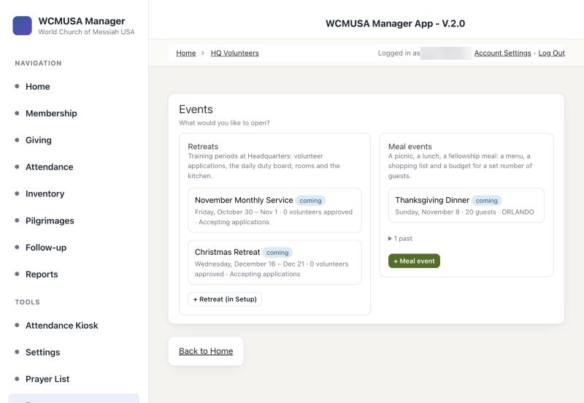
The Events chooser

Applications
The Applications tab lists everyone who has applied to serve during the retreat. Most applications come from the public volunteer form (see chapter 11); staff can also enter one.
At the top, three counts show the applications waiting for a decision, the number approved out of the places available, and those waitlisted or declined. Below them:
- A search box: “Search name, church or email”.
- A status filter: Every status, New, In review, Approved, Waitlisted, Declined, Withdrawn.
- + New application, and the address of the public form, ready to share.
The list on the left shows each applicant with their dates, member match, status and church. Approved people show their team. Click a row to open the application on the right: church, contact, the dates on site, the areas they would like to serve in, experience, lodging, endorsement, when and how it was sent, who decided, and Notes. National / Admin also see health, diet and the emergency contact.

The member match
When someone applies on the public form, the app looks for them among the members:
- Same email or same phone — the application is linked to that member at once. The list shows Linked.
- Same name only — the list shows Confirm. The application asks “Is this the same person?”. National / Admin click Same person: link to (the member’s name) or Different person: add a new member.
- Nobody found — a new member record is made as a Friend (Active) at the church the person chose. The list shows New member.

Endorsements
Before a volunteer is approved, their minister or regional leader endorses them. While none is recorded, the application shows “Waiting” under Endorsement.

How to record an endorsement
- Open the application.
- Under Endorsement, click Record endorsement.
- The application now shows “Endorsed” with your name, and the endorsement check is ticked.
Both National / Admin and Regional can record endorsements and write Notes.

How to approve a volunteer
Who can use this: National / Admin only.
- Open the application.
- If the match shows Confirm, settle it first: Same person: link to or Different person: add a new member.
- Tick all four checks in the checklist: Member record confirmed, Minister / regional endorsement received, Health and dietary notes read, Dates fit the period and capacity.
- Click Approve. The button stays grey until the match is confirmed and all four checks are ticked.
- The app places the person in the smallest team, from A to E, and says which one.
Instead of approving, you can click Waitlist or Decline. After any decision, Reopen puts the application back in review. Delete removes it. If the retreat is full, the app refuses the approval and asks you to waitlist the person or raise the capacity in Setup.
National / Admin can also change the person’s dates on site.

After approval: team, sleeping area and the approval email
- Under Team, change the team if needed. Changing it moves every day of their stay at once.
- Under Sleeping area, choose where the person sleeps. Each room shows how many beds are free; full rooms cannot be chosen. The app checks this night by night.
- Click Write the approval email. Your own email program opens with a ready-written message: dates, team, where they sleep, the first day’s duties and the daily routine.
- Check the message and press Send in your email program. The app does not send the email itself.
- Back in the app, click Mark as sent. The application then shows the date the approval email was sent, and Open the email again if you need it.
Tip: If your email program does not open, click Copy the text and paste it into a new email.

How to enter an application for someone
- On the Applications tab, click + New application.
- Find the person among the members, or click Add a new person and give first name, last name, email, phone and home church.
- Fill in the arrival and departure dates and whether they need lodging.
- Tick the areas they would like to serve in and their experience.
- Add health notes and an emergency contact.
- Click Save application.
A person can have only one application for the same training period.

Daily board
The Daily board shows who does what on each day of the retreat. Duties are worked out by the app from the teams; you never type them in. Each day the teams rotate to a different duty area, so the work is shared fairly. Kitchen and Household Cleaning are always covered first. When fewer than four people are on site, the day is a “Reduced crew” day: one person in each always-covered area, and everyone takes a second duty.
Choose By day or By person.
By day shows:
- The date with arrows to move day by day.
- Coordinator today — National / Admin choose the coordinator for the day.
- The routine for everyone, every day.
- A grid of duty areas by time block, with the team on duty, how many people are needed, the people (marked when they come from another area, arrive or leave that day, or are doing a second duty) and the tasks. National / Admin tick tasks as they are done.
- On site today (alphabetical or by team), Sleeping tonight (beds per room, and anyone without a place yet), and what is in season in the garden this month.
By person — choose a volunteer to see their area and tasks for every day of their stay.

How to print the duty sheet for a day
- Open Daily board, By day.
- Move to the day you want.
- Click Print this day. It prints sideways, with each area, its team, the names and tick boxes for the tasks.

Coverage
The Coverage tab is a calendar of the whole retreat. Each day is coloured: fine, reduced crew, or red when no one is on site. Each day also shows how many people are in the Kitchen and Household Cleaning. A headline at the top sums it up, for example “Kitchen and Household Cleaning are covered all 7 days”. Click a day to open it on the Daily board.

Kitchen
The Kitchen tab plans the meals and the shopping. It has seven parts: Menu, Shopping list, Recipes, In season, Pantry & fridge, Budget and Prices. Everyone who can open Events can read the kitchen. National / Admin change it for retreats; Regional change it only for their own churches’ meal events.
Important: Headquarters buys no dairy. Dairy items are left off the shopping list and flagged in recipes.
Menu. One row per day with the number of people eating (volunteers on site plus staff, or the guests of a meal event) and a recipe for Breakfast, Lunch and Dinner. You can type a different number of servings to override the head count.
Shopping list. Built from the menu for the dates in From and To (a week by default). For each item you see whether to buy, buy more or whether it is in stock, how much the meals use, how much you have, how many packages to buy, and the price at each store. Totals per store and the cheapest store for each item are shown. Choose the view Everything, By recipe or Restocking. The list also shows items left off because they are dairy, and items to check in the pantry.

How to use the shopping list
- Open Kitchen, then Shopping list.
- Set From and To.
- Click Print list for a clean list grouped by store, with tick boxes and subtotals.
- When you buy an item, click Bought, type the price paid and the store, and confirm. The item goes into the pantry.
- To add something not on the menu, use Add an item.
National / Admin can click Clear the list to remove items added by hand or from recipe cards that are not yet bought.
Recipes. The list of recipes, how many each serves, whether it is on the menu and whether it is in season. Open a recipe to read it, Print it, Edit it, see what it costs, or Add to the shopping list for a number of people.

How to add a recipe
- Open Kitchen, then Recipes.
- Click + New recipe to type it, or Upload a recipe (PDF, photo or text) to let the app read a file. A photo can take about a minute the first time.
- Check the ingredients. The app shows how it matched each ingredient to the price list.
- Click Save recipe.
In season. The crops that grow in the garden in the chosen month. Click a crop to add it to the shopping list.
Pantry & fridge. What is on hand in the pantry, fridge and freezer, with the minimum to keep, what was used in the last 30 days, and whether each item is OK, low or out. National / Admin record Count, Bought, Used and Thrown out. Meals take their ingredients out of the pantry automatically on their day. A meal event at a church uses that church’s own pantry, never Headquarters’.
Budget. The budget (by default $30 a person a day for a retreat, $10 a guest for a meal event), the estimated cost, the actual amount spent from receipts, and what is left. Click Add receipt to record a receipt with its date, store, total and a note.
Prices. The price list, with a column per store. Ralphs prices and US averages fill in automatically; prices for other stores are typed by hand with + price in that store’s column. Look up at Ralphs searches Ralphs for an item, and Refresh all Ralphs prices updates them all.

Meal events
Who can use this: National / Admin — at Headquarters or any church. Regional — at their own churches only.

How to create a meal event
- Click + Meal event on the chooser or inside Events.
- Type the Name (for example “Vegan picnic”) and the Date. For an event over several days, add the Last day.
- Enter the number of Guests and the Budget per guest (10 dollars by default).
- Under Where (whose pantry), choose Headquarters or the church. Regional see only their own churches.
- Click Create the event.
To change it later, open the event and click Edit event. The same form has Delete event.
A meal event has only Kitchen and Reports. It has no applications or duties and never appears on the public volunteer form.

Reports
The Reports tab sums up an event. Regional see their own churches only.
- Retreat: volunteers who came (first time and returning), days of service, applications from the public form, beds used, food cost, budget and amount spent; tables of who came by church, applications by status, duties checked off per area, lodging and kitchen, each volunteer’s times served, and every training period side by side. Click Print report to print it.
- Meal event: guests, budget, estimated food cost, amount spent, and the menu.

Setup
Who can use this: National / Admin only.
Setup holds everything the rest of Events is built on.
- Training periods — each retreat: name, start and end dates (quick buttons 3 days, 7 days, 10 days), capacity, staff eating, budget a person a day, status and deadline. Status is Accepting applications, In progress, Completed or Closed. Only periods with Accepting applications, not yet ended and before the deadline, appear on the public volunteer form.
- Price source — where prices come from, an organic adjustment, and Update the averages now. Under Ralphs prices, type a ZIP code, click Find Ralphs stores and then Use this store.
- Sleeping areas at HQ — rooms, beds and notes.
- Crops for the garden — what grows in which season.
- Duty areas — order, people needed, whether always covered, and colour.
- Duty tasks by time block — the tasks for each area in each part of the day. + Add a time block adds one.
- Daily routine for all participants — the start time and activity of each part of the day.

How to open a new retreat
- Open Events, then Setup.
- Under Training periods, fill in the name and the start date, and click 3 days, 7 days or 10 days (or type the end date).
- Enter the capacity, the deadline and the budget.
- Set the status to Accepting applications.
- Click Add.
The retreat now appears on the public volunteer form.

Quick reference
Task | Where | Who
Open a retreat or meal event | Events → chooser | National / Admin, Regional
Record an endorsement | Applications → Record endorsement | National / Admin, Regional
Approve, waitlist or decline | Applications → checklist → Approve | National / Admin
Send the approval email | Write the approval email → Mark as sent | National / Admin
Enter an application for someone | Applications → + New application | National / Admin
See or print today’s duties | Daily board → Print this day | National / Admin, Regional
Check the whole period is covered | Coverage | National / Admin, Regional
Plan meals and shopping | Kitchen → Menu, Shopping list | National / Admin; Regional for own meal events
Create a meal event | + Meal event → Create the event | National / Admin, Regional (own churches)
Print an event report | Reports → Print report | National / Admin, Regional
Open a new retreat | Setup → Training periods | National / Admin

11. Public pages
Videos for this chapter
- The public registration forms, step by step 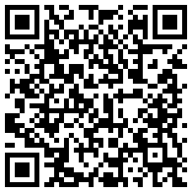
Three pages of the app are open to everyone, with no login: Pilgrimage Registration, Volunteer Application and the Attendance Kiosk. You share their links with members and friends, or open them on a tablet at a church table. These pages show no member records, so they are safe to leave open in public. The two registration forms also hide the app’s menu. What people send arrives in the app, where staff take it from there.
Who can use this: Anyone can fill in the public pages; no account is needed. The results are handled by staff: pilgrimage registrations by National / Admin and Regional (chapter 9), volunteer applications by National / Admin and Regional (chapter 10), and check-ins as described in chapter 4.

The links to share
Page | Link
Pilgrimage Registration | https://wcmusa.knack.com/manager-v2-app#pilgrimage-registration
Volunteer Application | https://wcmusa.knack.com/manager-v2-app#volunteer-application
Attendance Kiosk | https://wcmusa.knack.com/manager-v2-app#attendance-kiosk

How to share a link
- Copy the link from the table above.
- Paste it into an email, a message, the church newsletter or the website.
- To put it on a printed flyer, turn the link into a QR code with any QR code maker, so people can open it with their phone camera.
Tip: The address of the volunteer form is also shown on the Applications tab in Events, ready to copy.

Pilgrimage Registration
This is the form pilgrims use to register for a pilgrimage. It lists every trip whose status is Open. If no trip is open, the page says “There is no pilgrimage open for registration right now.”
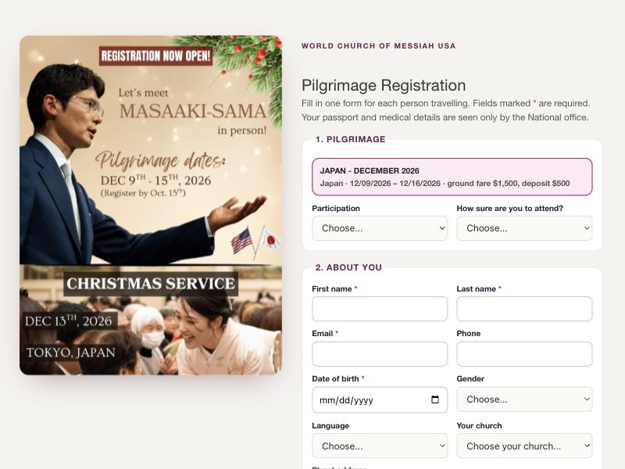
The Pilgrimage Registration page with a trip poster

What the public sees
The page has the heading Pilgrimage Registration. It explains that each person travelling fills in their own form, and that passport and medical details are seen only by the National office.
The poster. If the trip has a poster, it is shown whole beside the form, or above the form on a phone. To add or change the poster, edit the trip on the Pilgrimages page and use Poster (shown on the public registration page) (see chapter 9).
The form has numbered sections:
- Pilgrimage — a card for each open trip, with its country, dates, ground fare and deposit; whether the person comes for the whole pilgrimage; and how sure they are to attend.
- About you — first name, last name, email, phone, date of birth, gender, language, church and address.
- Passport and travel — citizenship, passport number and expiry date, an optional passport photo (JPG or PNG, up to 5 MB), and whether they need a travel visa.
- Flights — the journey there and back (see below).
- Stay — room preference, whether they stay with the group the whole time, nights, and home stay.
- Health.
- Emergency contact.
- Insurance.
- Japan — shown only for a trip to Japan.
- Acknowledgements — all four must be ticked.
First name, last name, a valid email, date of birth, the trip and all four acknowledgements are required. The form says what is missing.
Flights as a journey. The flights section has two parts, “Going to the pilgrimage” and “Returning home”, each starting with one flight. + Add a connecting flight adds the next leg, starting where the last one landed. As the person types, the layover time appears, with a warning if a flight leaves before the previous one lands. Someone who has not bought tickets yet ticks I haven’t bought my flights yet and sends them to the church office later.
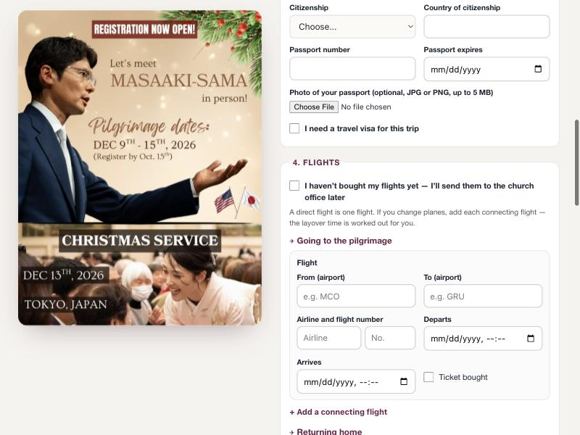
The flights section with a connecting flight

How a pilgrim registers
- Open the Pilgrimage Registration link.
- Choose the trip.
- Fill in each section.
- Tick the four acknowledgements.
- Click Send my registration.
- The page thanks the person by name and shows their application number.

Using the form at a church table (kiosk mode)
Because the page hides the app’s menu, you can leave it open on a tablet or laptop at a church table and let people register one after another.
- Open the Pilgrimage Registration link on the device.
- Let the first person fill in the form and click Send my registration.
- On the thank-you screen, click Register another person. The form is cleared for the next person.
Important: Each email address can register only once for the same trip. If family members share one email, only the first can register online; ask the others to use their own email, or contact the National office.

What staff do with a registration
Every registration appears at once on the Roster tab of the Pilgrimages page, as Pending, Unpaid and “not linked”. Then staff:
- Click Link to member to connect the pilgrim to their member record.
- Link payments once they are recorded on the Giving page.
- Change the status to Confirmed when the pilgrim is accepted.
- Add the name in katakana and the position, and check the flights (National / Admin).
See chapter 9 for each step.

Volunteer Application
This is the form people use to apply to serve at Headquarters during a training period (a retreat). It lists the periods that are accepting applications. If none is open, the page says “No training period is open for applications right now.”
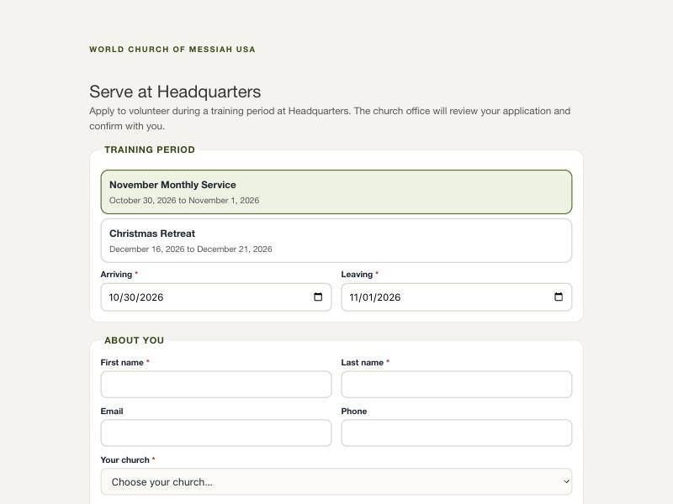
The Volunteer Application page

What the public sees
The page has the heading Serve at Headquarters. The sections are:
- Training period — a card for each open period, with the arrival and departure dates (limited to that period).
- About you — first name, last name, email, phone and church. The person gives an email, a phone number, or both.
- How you would like to serve — the duty areas they would like and their experience.
- Health and safety — health limits, allergies and diet, an emergency contact and phone, and whether they need lodging at Headquarters.
- An agreement to follow the daily schedule and the coordinator’s direction during the stay.

How a volunteer applies
- Open the Volunteer Application link.
- Choose the training period and the arrival and departure dates.
- Fill in the sections.
- Tick the agreement.
- Click Send my application.
- The page thanks the person and says the church office will review the application and confirm.
- To enter another person on the same device, click Apply for another person.
A person can apply only once for the same period. The page never shows which member record the person was matched with.

What staff do with an application
The application appears on the Applications tab in Events. The app matches it to a member by email or phone, asks staff to confirm when only the name matches, or makes a new member record as a Friend. Staff then record the endorsement, approve the volunteer and send the approval email. See chapter 10.

Attendance Kiosk
The Attendance Kiosk lets members check themselves in at a service, usually on an iPad at the church entrance. A member scans their card’s QR code or searches for their name, and the check-in is recorded for that church. Chapter 4 explains how to set it up and use it.
To open the kiosk straight on one church, add the church to the link, for example https://wcmusa.knack.com/manager-v2-app#attendance-kiosk?church=ORLANDO. Without it, the kiosk finds the nearest church from the device’s location, or asks which church to use.
Check-ins appear in the church’s attendance like any other.
The Attendance Kiosk on a tablet

Quick reference
Task | Where | Who
Share the pilgrimage form | #pilgrimage-registration link | Anyone
Register several people at one table | Register another person | Anyone
Change the poster on the form | Pilgrimages → edit the trip → Poster | National / Admin
Handle new registrations | Pilgrimages → Roster | National / Admin, Regional
Share the volunteer form | #volunteer-application link | Anyone
Handle volunteer applications | Events → Applications | National / Admin, Regional
Open the kiosk for one church | #attendance-kiosk?church= link | Anyone

12. Settings
Videos for this chapter
- Managing the church list, step by step 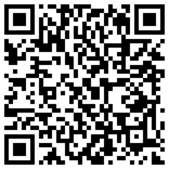
The Settings page keeps the list of churches up to date: each church’s name, region and address. The address also places the church on the map, so the app can find each member’s nearest church. This chapter also explains how church access decides what each account sees, and where to change your own name, email and password.
Who can use this: Only National / Admin can open the Settings page and change the church list. Regional, Admin Assistant and Local see the message “Only administrators may change the church list.” Everyone can change their own name, email and password.

The Settings page
Click Settings in the left menu. If the app asks you to sign in, sign in with your own account. Only National / Admin accounts are let in.
The page shows the heading Churches, with a line telling you how many churches are on file and how many have no location. A church without a location cannot be anyone’s nearest church on the map.
The table has these columns:
- Church
- Region
- Street
- City / State / Zip
- Coordinates, with the label on the map in green or not located in red.
Each row has an Edit button.
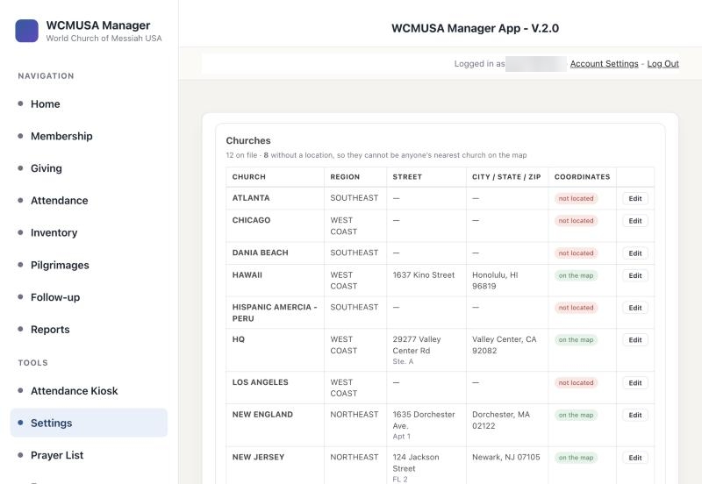
The Settings page with the list of churches

Adding and editing churches

How to add a church
- Click Add a church. A new, empty row opens at the top of the table.
- Type the name of the church.
- Choose the Region.
- Fill in Street, Suite / unit if there is one, City, ST (the two-letter state) and Zip.
- Leave the coordinates box empty. The app fills it in from the address.
- Click Save. The message reads “Looking up the address…” and then “Church added.”

How to edit a church
- Click Edit on the church’s row.
- Change the name, region or address.
- Click Save. The message reads “Saved.” To leave without changing anything, click Cancel.

When an address cannot be found
If the app cannot find the address, the message reads “Saved, but that address could not be found, so it will not appear on the map.” The church is saved, but shows not located.
- Check the street and zip, and correct them if needed.
- Click Save again.
If the address is right but still not found, for example a rural address, you can place the church yourself:
- Click Edit on the row.
- In the last column, type the latitude and longitude, separated by a comma, for example 33.2296,-117.0205.
- Click Save.
Coordinates you type yourself always take priority over the address lookup.
Tip: To find a church’s coordinates, look up the address in an online map and copy the latitude and longitude it shows.

Closing a church
Churches cannot be deleted. Members, donations, reports and deposits are all linked to them, and removing a church would leave those records without a church. When a church closes, leave it in the list.

Regions
The Region list offers the regions that already exist. There is no screen in the app to add a new region. Ask your app administrator if a region is needed.

Church access: what each account sees
Each account has a list of churches it looks after, called its church access. This decides what the account sees all through the app:
- National / Admin sees every church.
- Regional, Admin Assistant and Local see only the members, donations, attendance, stock and reports of the churches in their church access.
- An account with no churches in its church access sees no figures. Most pages show a short message saying so.
Every page in the left menu opens for every signed-in user. What changes from one account to another is the information inside.
Accounts and their church access are set up by your app administrator. There is no screen for them in the app. If you see the message that your account has no church access, or you are missing a church you look after, ask your administrator.

Your own account
Everyone can change their own details on the Account Settings page.
Click Account Settings at the top right of any page, next to your name and Log Out. Chapter 1 explains the steps.

How to change your name or email
- Click Account Settings at the top right of the page.
- Change Name or Email.
- Click Submit.

How to change your password
- Click Account Settings at the top right of the page.
- In Change Password, type your Current Password, then the new password twice.
- Click the button under the box to save.
The Account Settings page

Other settings for National / Admin
The settings for importing online donations, such as the last Zeffy and Stripe sync times, are on the Import Donations page. They are explained in chapter 6.

Quick reference
Task | Where | Who
See the list of churches | Settings | National / Admin
Add a church | Settings, Add a church | National / Admin
Change a church’s name, region or address | Settings, Edit | National / Admin
Place a church on the map by hand | Settings, Edit, coordinates column | National / Admin
Add a region, or change an account’s church access | Ask your app administrator | Administrator
Change your own name, email or password | Account Settings | Everyone

